**Industry Work**

**Semester-8**

**Internship**

**Developed By: - Guided By: -**

Vismay_Patel (20162101015) Prof Neha Sisodiya (Internal)

**Submitted to**

**Faculty of Engineering and Technology**

**Institute of Computer Technology**

**Ganpat University**



**Year - 2024**



**CERTIFICATE**

This is to certify that the **industry work** entitled “React js training” by **Vismay Patel (20162101015)** of Ganpat University, towards the partial fulfillment of requirements of the degree of Bachelor of Technology – Computer Science and Engineering, carried out by them in the CSE(CBA) Department at **Silicon It Hub**. The results/findings contained in this Project have not been submitted in part or full to any other University / Institute for award of any other Degree/Diploma.

Name & Signature of Internal Guide

Name & Signature of Head

**Place: ICT-GUNI**

**Date: 12-05-2024**

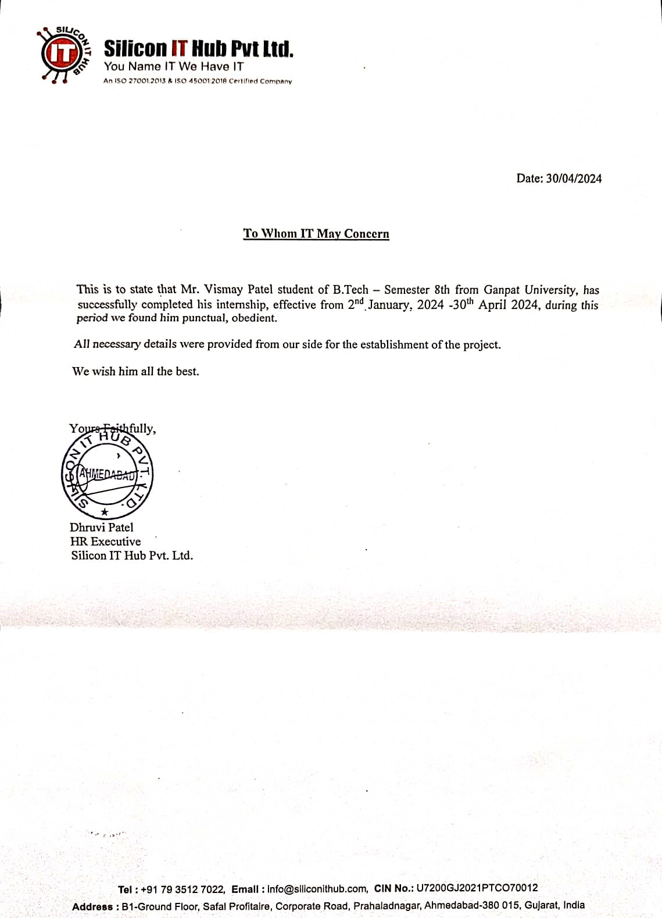

**ACKNOWLEDGEMENT**

Undoubtedly, my industry internship has been a valuable opportunity for learning and self-development. I'm grateful to Dr. Rohit Patel, Principal of ICT, and Prof. Dharmesh Darji, Head of ICT, for entrusting me with task-based responsibilities. Special thanks to Prof. Neha Sisodiya for their guidance. I'm particularly appreciative of the training in React JS, which has equipped me with essential skills for my tasks. The support from the CSE department has been invaluable. Each contribution has played a crucial role in my professional growth. Thank you all sincerely for your support and mentorship.

**Vismay Patel (20162101015)**

**TABLE OF CONTENT**

|  |  |  |  |
| --- | --- | --- | --- |
| **Title** | | | **Page Number** |
| **1.** | **Overview of the Company** | | 7 |
|  | 1.1 | About Us | 7 |
|  | 1.2 | Services | 7 |
|  | 1.3 | Industry | 7 |
| **2** | **Week-1 Progress** | | 8 |
|  | 2.1 | Objective | 8 |
|  | 2.2 | Accomplishments | 8 |
|  | 2.3 | Conclusion | 8 |
| **3** | **Week-2 Progress** | | 9 |
|  | 3.1 | Objective | 9 |
|  | 3.2 | Accomplishments | 9 |
|  | 3.3 | Conclusion | 9 |
| **4** | **Week-3 Progress** | | 10 |
|  | 4.1 | Objective | 10 |
|  | 4.2 | Accomplishments | 10 |
|  | 4.3 | Conclusion | 10 |
| **5** | **Week-4 Progress** | | 11 |
|  | 5.1 | Objective | 11 |
|  | 5.2 | Accomplishments | 11 |
|  | 5.3 | Conclusion | 11 |
|  | 5.4 | Screenshot | 12 |
| **6** | **Week-5 Progress** | | 13 |
|  | 6.1 | Objective | 13 |
|  | 6.2 | Accomplishments | 13 |
|  | 6.3 | Conclusion | 13 |
|  | 6.4 | Screenshot | 14 |
| **7** | **Week-6 Progress** | | 15 |
|  | 7.1 | Objective | 15 |
|  | 7.2 | Accomplishments | 15 |
|  | 7.3 | Conclusion | 15 |
|  | 7.4 | Screenshot | 16 |
| **8** | **Week-7 Progress** | | 17 |
|  | 8.1 | Objective | 17 |
|  | 8.2 | Accomplishments | 17 |
|  | 8.3 | Conclusion | 17 |
|  | 8.4 | Screenshot | 18 |
| **9** | **Week-8 Progress** | | 22 |
|  | 9.1 | Objective | 22 |
|  | 9.2 | Accomplishments | 22 |
|  | 9.3 | Conclusion | 22 |
| **10** | **Week-9 Progress** | | 23 |
|  | 10.1 | Objective | 23 |
|  | 10.2 | Accomplishments | 23 |
|  | 10.3 | Conclusion | 23 |
| **11** | **Week-10 Progress** | | 24 |
|  | 11.1 | Objective | 24 |
|  | 11.2 | Accomplishments | 24 |
|  | 11.3 | Conclusion | 24 |
|  | 11.4 | Screenshot | 25 |
| **12** | **Week-11 Progress** | | 26 |
|  | 12.1 | Objective | 26 |
|  | 12.2 | Accomplishments | 26 |
|  | 12.3 | Conclusion | 26 |
|  | 12.4 | Screenshot | 27 |
| **13** | **Week-12 Progress** | | 32 |
|  | 13.1 | Objective | 32 |
|  | 13.2 | Accomplishments | 32 |
|  | 13.3 | Conclusion | 32 |
|  | 13.4 | Screenshot | 33 |
| **14** | **Week-13 Progress** | | 36 |
|  | 14.1 | Objective | 36 |
|  | 14.2 | Accomplishments | 36 |
|  | 14.3 | Conclusion | 36 |
|  | 14.4 | Screenshot | 37 |
| **15** | **Week-14 Progress** | | 40 |
|  | 15.1 | Objective | 40 |
|  | 15.2 | Accomplishments | 40 |
|  | 15.3 | Conclusion | 40 |
|  | 15.4 | Screenshot | 41 |
| **16** | **Week-15 Progress** | | 43 |
|  | 16.1 | Objective | 43 |
|  | 16.2 | Accomplishments | 43 |
|  | 16.3 | Conclusion | 43 |
|  | 16.4 | Screenshot | 44 |
| **17** | **Week-16 Progress** | | 50 |
|  | 17.1 | Objective | 50 |
|  | 17.2 | Accomplishments | 50 |
|  | 17.3 | Conclusion | 50 |
|  | 17.4 | Screenshot | 51 |
| **18** | **Week 17 Progress** | | 56 |

**Overview of the Company**

* 1. **About Us:**

Silicon IT Hub is a future-ready web and mobile app development company serving to drive the digital revolution. Since its inception in 1998, our friendly and diverse team of 200+ professionals aiding businesses of every niche globally.

Silicon encourages seamless growth for every workforce, client, and the whole company in the context of commercial revenue, expertise, and solutions. We provide a convenient and fully transparent work environment that motivates employees to be unique in everything they do.

**1.2 Services:**

* Mobile App Development
* Web Development
* Software Development
* UI/UX Design
* Product Engineering
* Enterprise Solutions
* QA
* Digital Marking
  1. **Industry:**
* Health Care
* Education/eLearning
* Retail
* Travel and Hospitality
* FinTech
* Media and Entertainment
* Real Estate

**Week 1**

**Objective:**

During Week 1's training, our primary aim was to furnish participants with a comprehensive grasp of JavaScript, encompassing its basic syntax, diverse data types, and fundamental programming principles.

**Accomplishments:**

* **Introduction to JavaScript**: Participants were immersed in the versatile world of JavaScript, a prominent programming language renowned for its application in web development. We underscored JavaScript's pivotal role in augmenting web pages with interactivity and dynamism, thereby elevating user experience.
* **Basic JavaScript Syntax:** We delved into the foundational elements of JavaScript syntax, acquainting participants with variables, data types (such as strings, numbers, arrays, and objects), and the significance of semicolons, parentheses, and curly braces in maintaining code structure.
* **Control Structures and Functions**: Participants were introduced to control structures like conditional statements (if-else) and loops (for, while), vital for implementing decision-making and iterative processes in JavaScript programs. Additionally, we explored the concept of functions as reusable code blocks, covering declaration, invocation, parameters, and return values.

**Conclusion:**

Throughout the training, our approach of interactive lectures coupled with hands-on exercises proved instrumental in fostering a robust understanding of JavaScript concepts. We witnessed active engagement from participants, evident through their participation in Q&A sessions and discussions. Despite challenges faced by some in grasping fundamental concepts and encountering syntax errors, our tailored solutions, including additional explanations, examples, and practice exercises, ensured a holistic learning experience. As Week 1 drew to a close, participants emerged equipped with newfound JavaScript proficiency, laying a solid foundation for their journey in web development.

**Week 2**

**Objective:**

This training aimed to equip participants with proficiency in jQuery and introduce supplementary tools and plugins used in web development to enhance user experience and functionality.

**Accomplishments:**

* **Mastery of Basic jQuery Functions:** Participants gained mastery over fundamental jQuery functions, enabling dynamic manipulation of DOM elements and CSS properties on web pages.
* **Exploration of jQuery Effects:** Through exploration of jQuery effects, participants acquired skills in crafting dynamic animations and transitions, enriching user interactions.
* **Proficiency in jQuery Traversing:** Participants mastered jQuery traversing methods, facilitating efficient navigation of complex HTML structures and precise element selection.
* **Implementation of Ajax Functionality:** Successful implementation of Ajax functionality enabled dynamic data retrieval and manipulation without page reloads, enhancing interactivity.
* **Exploration of Additional Tools and Plugins:** Participants explored additional tools and plugins such as slick slider carousels and modal dialogs, expanding their toolkit for creating feature-rich web interfaces.

**Conclusion:**

This training equipped participants with advanced jQuery skills and an expanded toolkit, poised to significantly enhance the creation of dynamic and engaging web applications, ultimately improving user experience and engagement.

**Week 3**

**Objective:**

Week 3 of the training was dedicated to React.js, focusing on equipping participants with a thorough understanding of this powerful JavaScript library for building interactive user interfaces. The objective was to guide participants through the process of building a todo app using React.js.

**Accomplishments:**

* **Introduction to React.js:** Participants grasped React.js's component-based architecture for constructing dynamic and interactive user interfaces efficiently.
* **JSX Syntax:** Mastery of JSX syntax enabled participants to declaratively define UI elements by combining HTML-like syntax with JavaScript expressions.
* **Component Composition:** Understanding component composition facilitated the creation of reusable and modular UI components, allowing participants to build complex interfaces by nesting and composing components.
* **State Management:** Participants learned essential concepts of managing component state and passing props between components to facilitate data flow, crucial for React development.
* **Advanced Topics:** Exploration of lifecycle methods, React Router for client-side routing, and state management tools like Context API and Redux provided participants with essential tools and techniques to enhance their React development skills.

**Conclusion:**

Participants gained a comprehensive understanding of React.js and built a todo app, honing skills in component composition, state management, routing, and styling, preparing them for developing robust user interfaces.

**Week 4**

**Objective:**

The project aimed to create a registration form using React.js, incorporating functionalities for data management such as storing data on local storage, rendering it into a table, and enabling CRUD operations. Additionally, the project involved fetching and displaying data from an external file and utilizing a modal to enhance user interaction.

**Accomplishments:**

* **Creation of Registration Form:** Developed a React.js component for the registration form with input fields and implemented form validation for data integrity.
* **Data Storage on Local Storage**: Integrated local storage functionality to persist user registration data, ensuring data persistence across browser sessions.
* **Rendering Data into a Table:** Designed a table component to display registered user data dynamically retrieved from local storage and an external JSON file.
* **Implementation of CRUD Operations:** Enabled CRUD functionalities for adding, editing, and deleting table entries, enhancing user data management capabilities.
* **Utilization of Modal to Display Data:** Integrated a modal component to display detailed user information, improving the user experience by providing a clutter-free interface for viewing additional data.

**Conclusion:**

The project successfully achieved its objective by developing a functional registration form with robust data management capabilities. Through the implementation of CRUD operations, rendering data from external sources, and enhancing user experience with modal windows, the project demonstrated effective utilization of React.js for building dynamic and interactive web applications.

**Screen shots:**

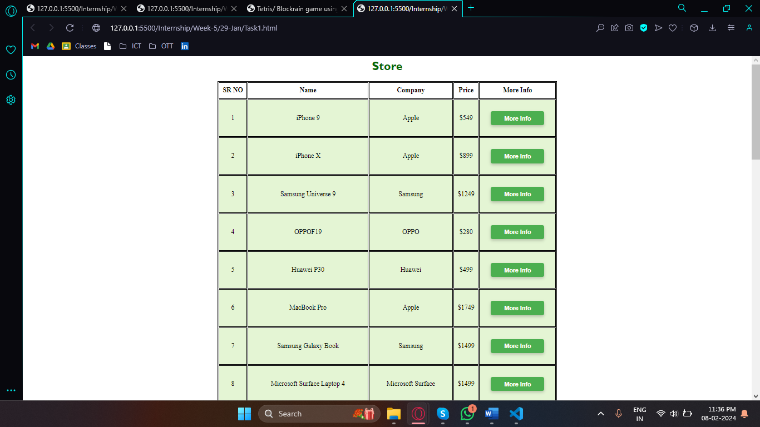

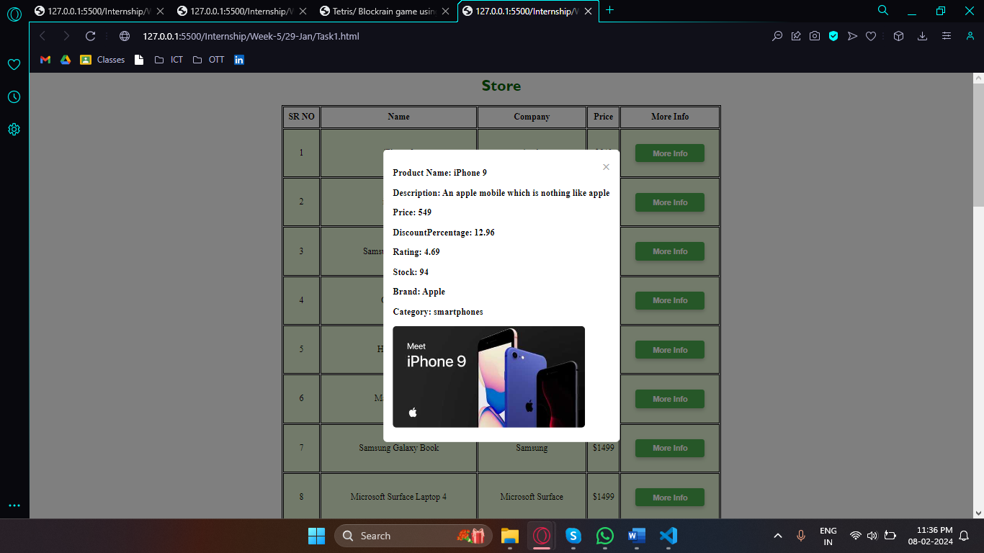

**Week 5**

**Objective:**

The objective of this learning module was to attain proficiency in JavaScript-based form validation techniques and explore popular validation plugins for simplifying validation tasks in web development projects.

**Accomplishments:**

* **Form Structure and Input Fields:** Designed and implemented the registration form UI with input fields for capturing user details such as name, email, password, etc.
* **Validation Logic:** Implemented JavaScript-based validation logic to enforce validation rules for each form field, including required fields, email format validation, password strength requirements, etc.
* **Error Handling and Feedback:** Provided clear and informative error messages to users when validation errors occur, guiding them on how to correct their inputs. Implemented visual feedback mechanisms such as highlighting invalid fields or displaying error messages next to the corresponding fields.
* **Submission Handling:** Prevented form submission if validation errors were detected, ensuring that only valid data is submitted to the server. Implemented client-side confirmation dialogs or notifications to inform users of successful form submission upon validation success.
* **User Experience Enhancement:** Improved the overall user experience by implementing efficient and robust form validation, contributing to enhanced usability and satisfaction.

**Conclusion:**

Through the completion of this module, participants successfully mastered JavaScript-based form validation techniques and gained insight into popular validation plugins. By implementing comprehensive validation logic and adhering to best practices, they enhanced the usability and data integrity of web forms, contributing to a seamless user experience.

**Screen shots:**

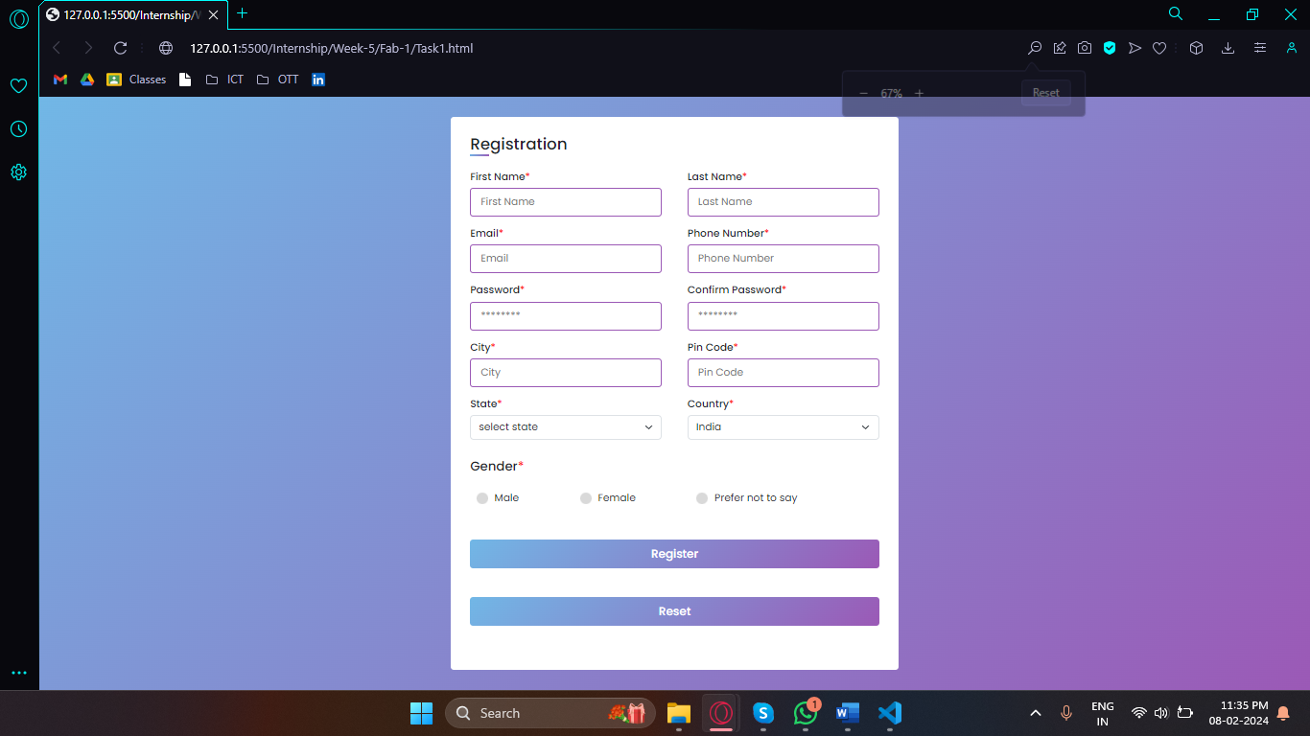

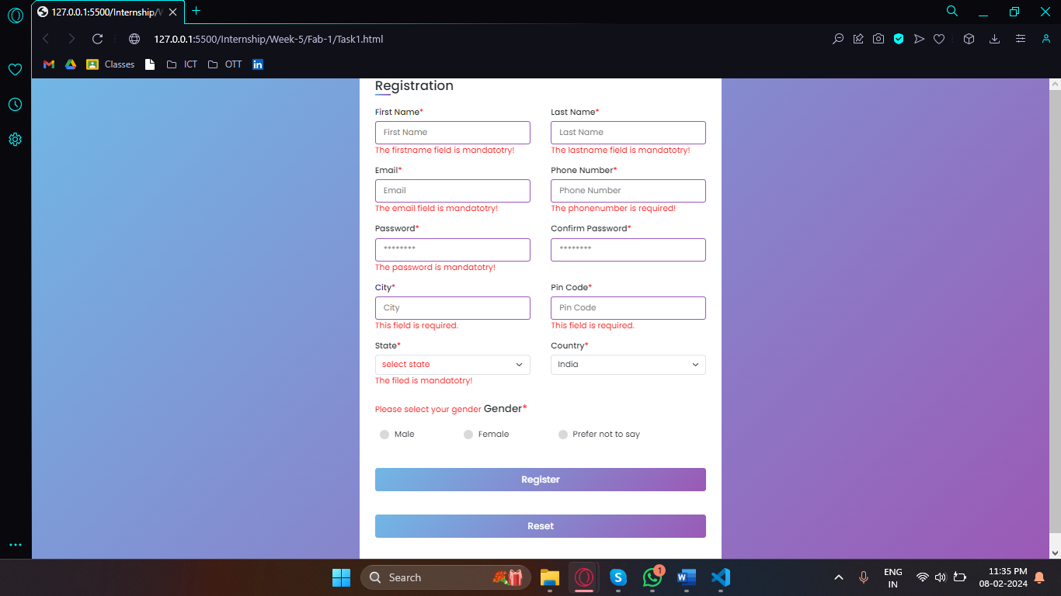

**Week 6**

**Objective:**

Week 6 aimed to deepen understanding and proficiency in React.js development by exploring fundamental concepts and implementing practical projects.

**Accomplishments:**

* **React.js Fundamentals Exploration:** Extensively delved into the create-react-app documentation to understand core concepts and best practices, covering JSX syntax, component architecture, state management, and props passing.
* **Weather App Implementation:** Successfully built weather applications using both jQuery and React.js, integrating the Open Weather API for data retrieval. Developed user-friendly interfaces enabling seamless weather checking for various locations, leveraging React.js for dynamic and responsive UI components.
* **Interactive Counter Creation:** Developed interactive counters using React.js, incorporating functionalities like start, pause, and reset. Utilized React.js state management to handle counter values dynamically, ensuring smooth functionality and user interaction.
* **Utilization of create-react-app:** Leveraged the create-react-app tool for efficient project setup, optimization, and advanced usage. Utilized features such as hot reloading, code splitting, and production build optimizations to streamline the development process.

**Conclusion:**

Week 6 provided a robust foundation in React.js development, covering fundamental concepts and practical implementations. Through exploration and project work, participants gained proficiency in creating dynamic user interfaces, managing state effectively, and optimizing development workflows. These accomplishments equip us with the skills and knowledge necessary to tackle React.js projects confidently and efficiently in future endeavors.

**Screen Shots:**

* **Using js**

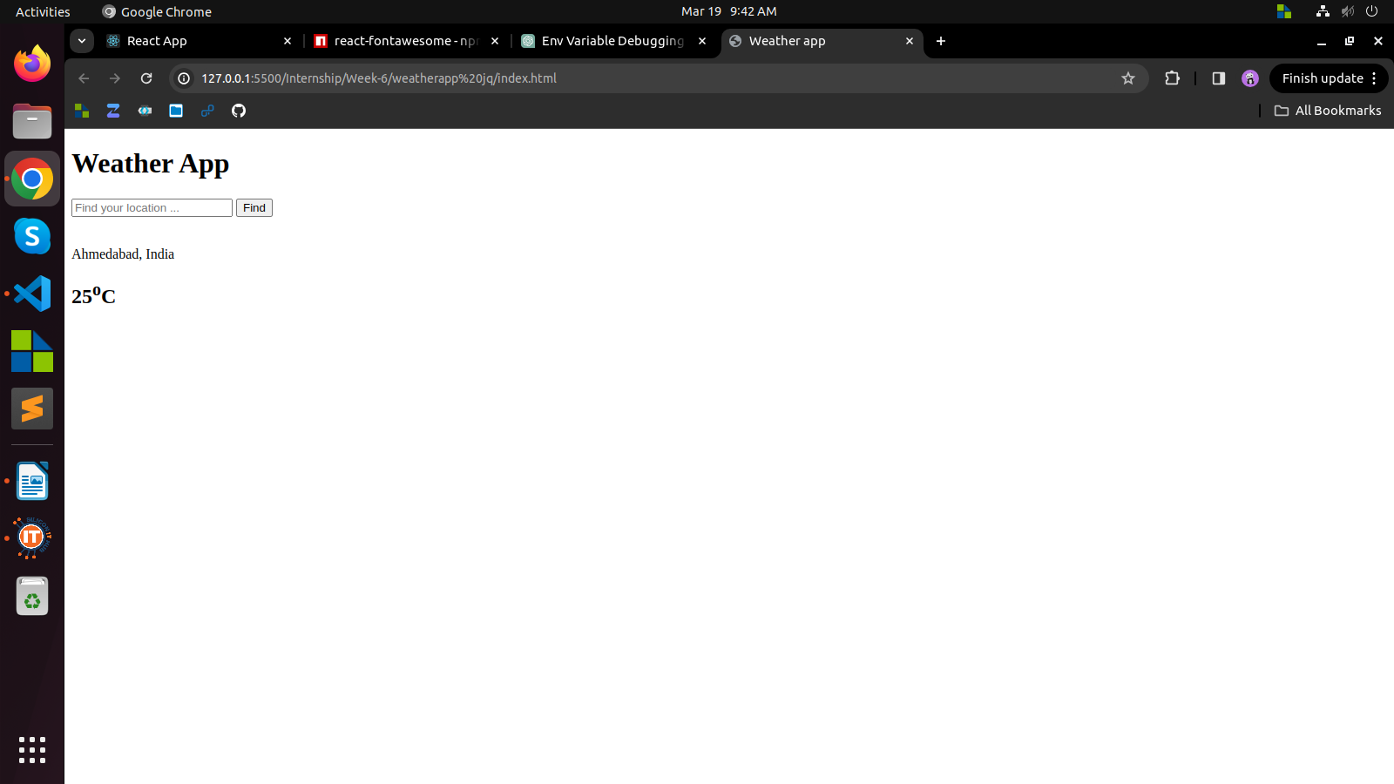

* **Using react**

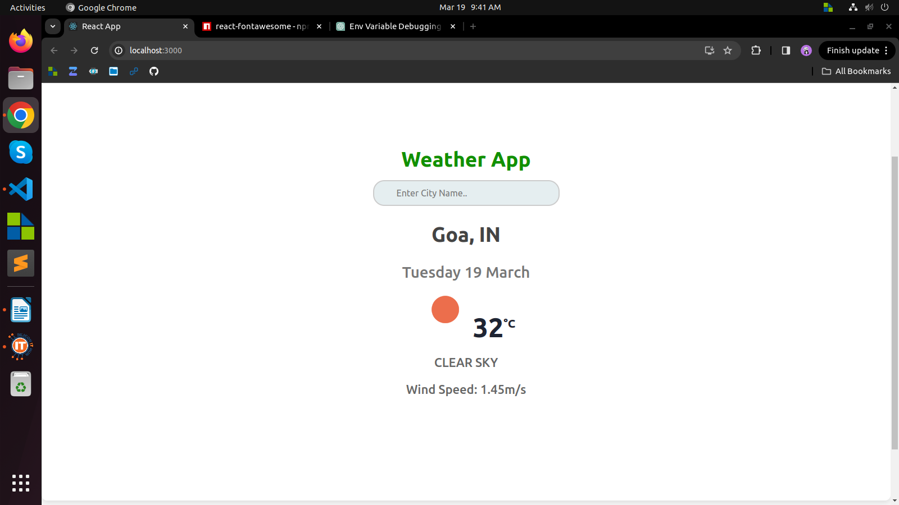

**Week 7**

**Objective:**

The objective across these projects was to create efficient and user-friendly web components and applications to enhance productivity and user experience.

**Accomplishments:**

**Appointment Booking Website:**

* Implemented secure authentication functionalities for user access.
* Developed an intuitive appointment booking form for convenient scheduling.
* Created separate dashboards tailored to the needs of doctors and users.
* Incorporated a modal component for detailed appointment viewing.

**Search Filter Component in React:**

* Developed a reusable search filter component with dynamic search capabilities.
* Implemented filtering functionalities based on various criteria.
* Ensured responsiveness and compatibility across different devices.

**Task Management Application:**

* Developed task management features for adding, editing, and organizing tasks effectively.
* Implemented filtering and sorting functionalities for streamlined task organization.
* Designed a user-friendly interface to enhance task management and navigation.

**Conclusion:**

These projects successfully addressed their respective objectives by delivering intuitive and efficient web components and applications. Moving forward, further enhancements such as additional features, optimization for larger datasets, and integration of real-time updates can further improve the functionality and user experience of these projects.

**Screen Shots:**

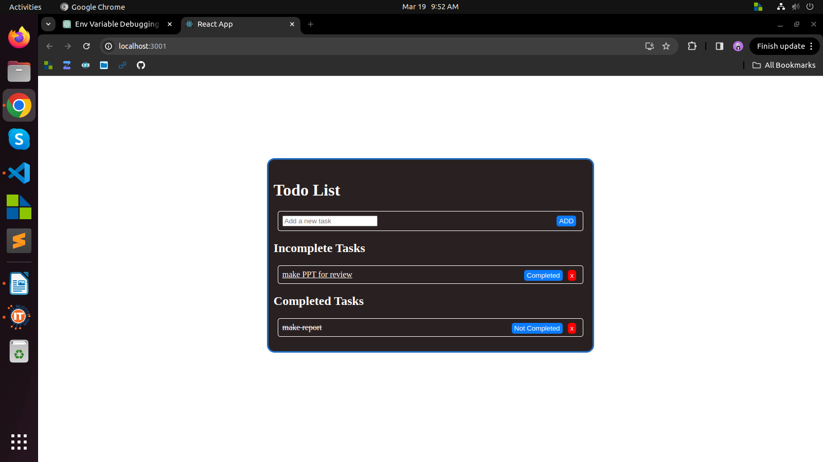

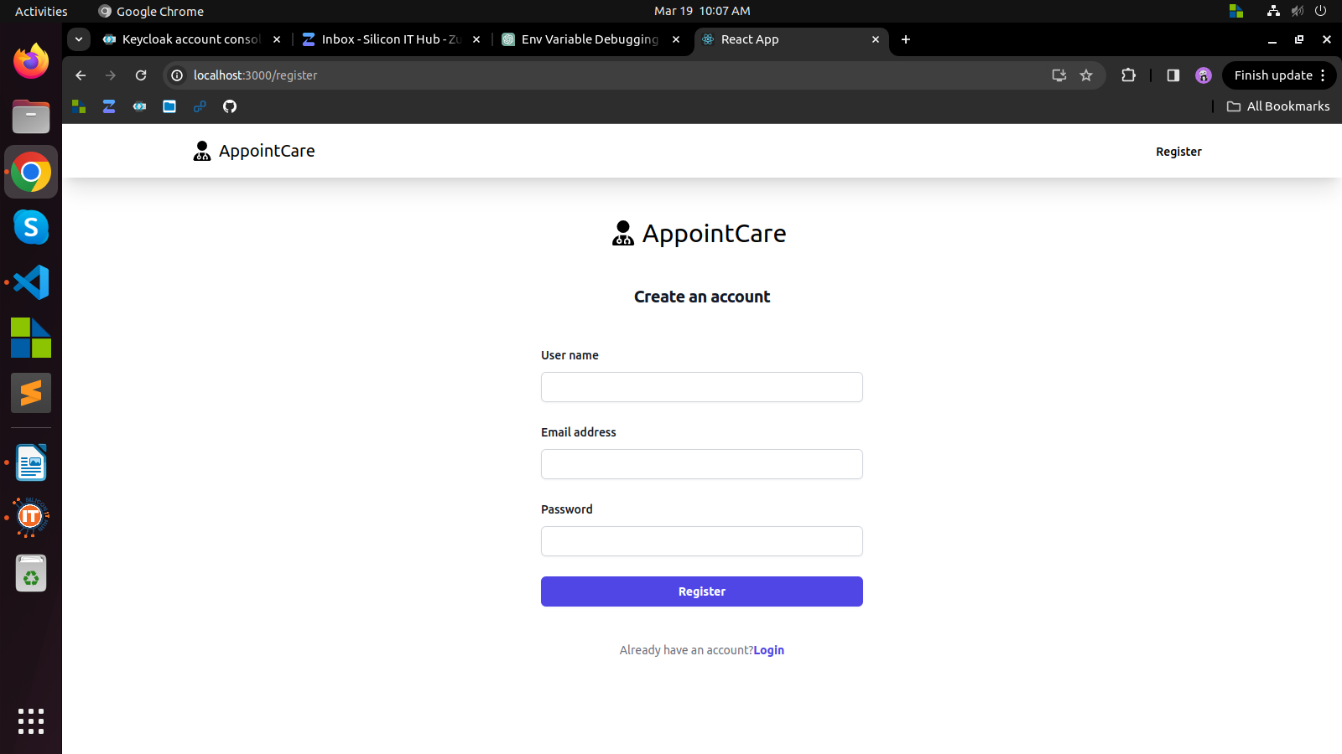

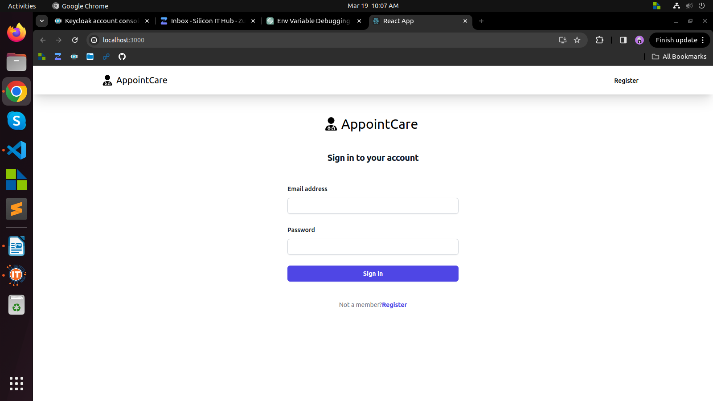

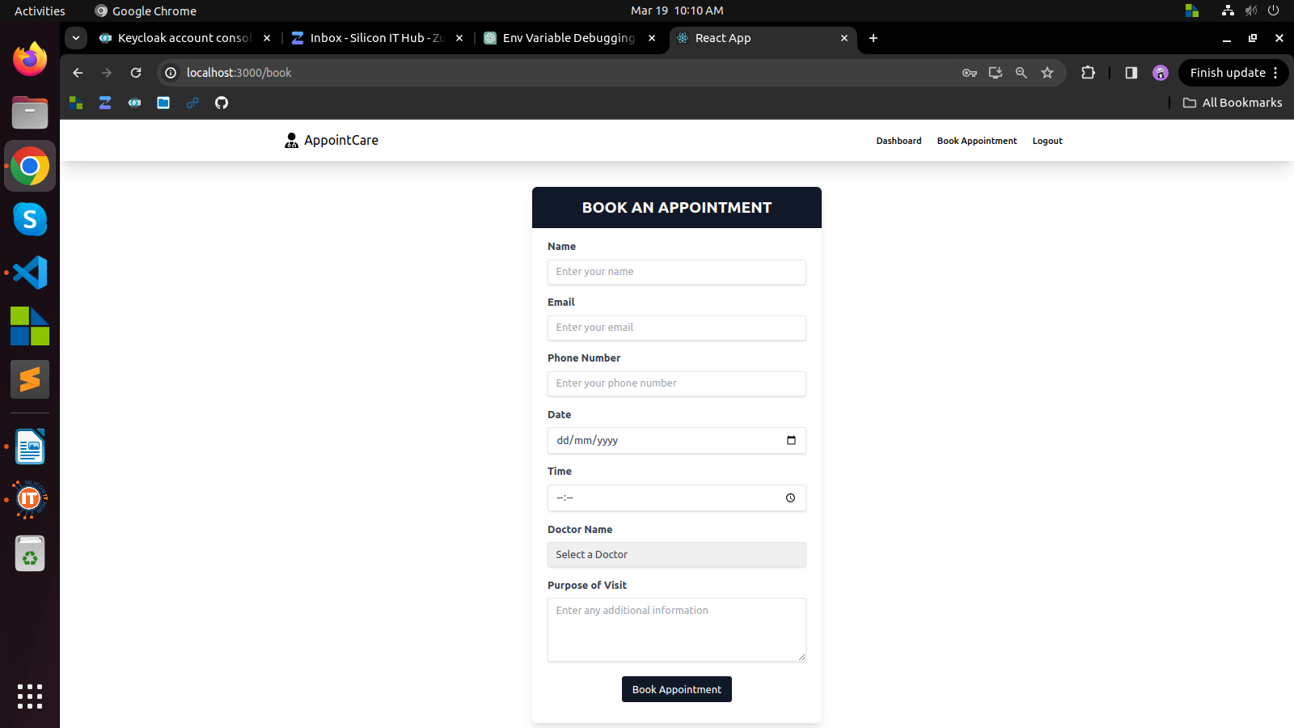

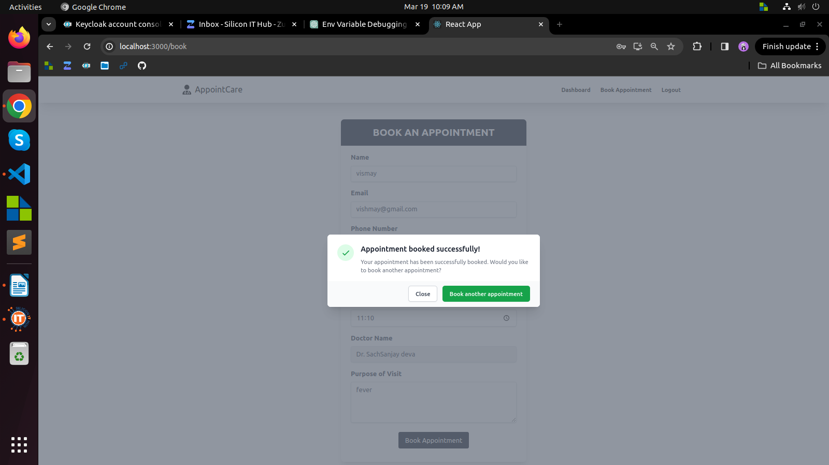

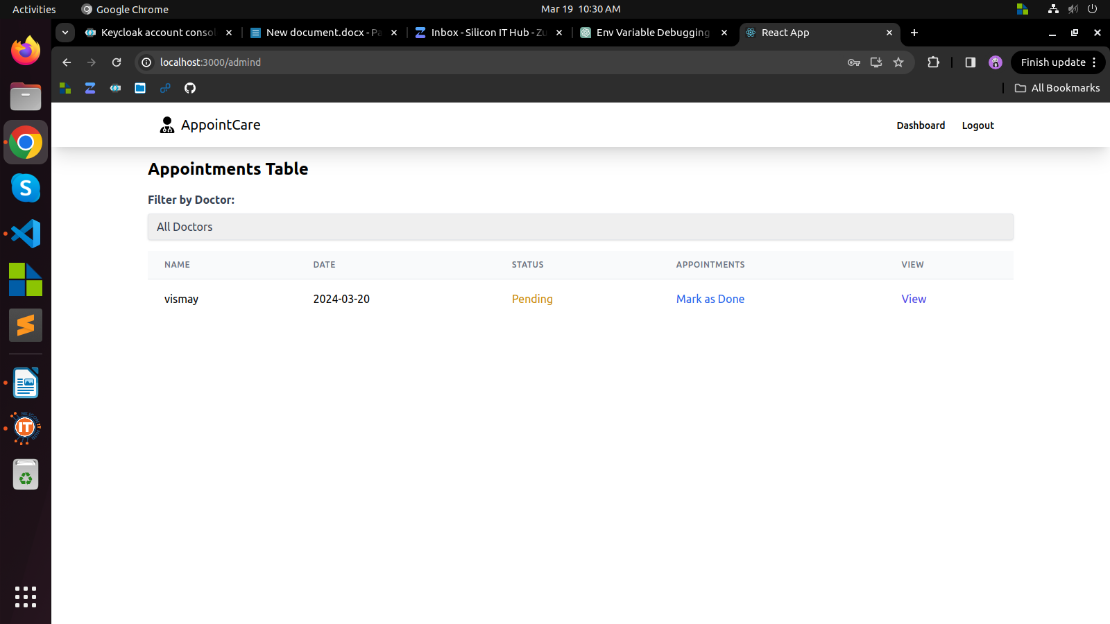

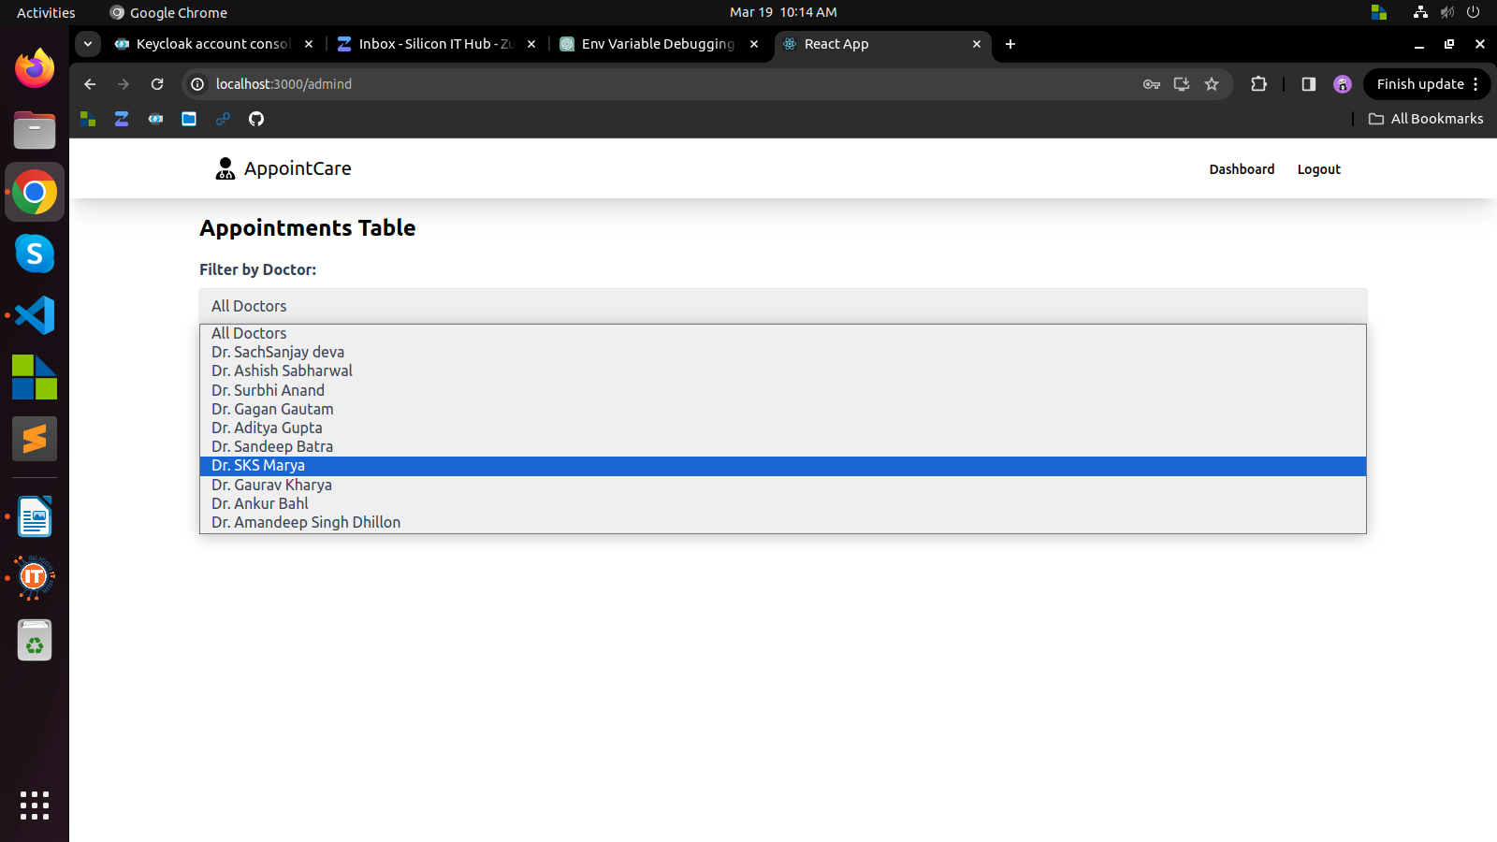

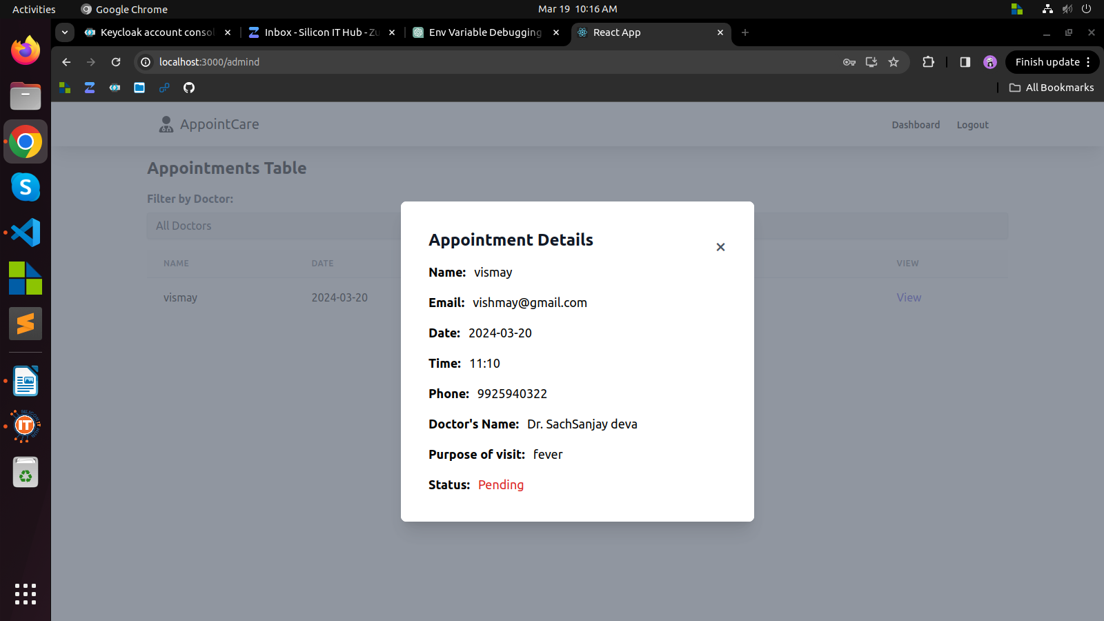

**Week 8**

**Objective:**

Our objective this week was to develop a dynamic job role management system that allows for seamless addition or removal of job roles based on organizational needs. Additionally, we aimed to streamline the employee registration process and provide an insightful dashboard for centralized employee management.

**Accomplishments:**

**Dynamic Job Role Management:**

* Implemented a flexible system allowing for the dynamic addition or removal of job roles, facilitating quick adaptation to changing organizational requirements.
* Developed intuitive interfaces for administrators, enabling easy management of job roles without necessitating technical expertise.

**Simplified Employee Registration:**

* Streamlined the employee registration process by creating user-friendly forms to capture essential information such as personal details, contact information, and job preferences.
* Employed validation techniques to ensure accurate data entry and minimize errors during registration.

**Insightful Dashboard:**

* Designed and implemented a centralized dashboard providing comprehensive insights into all employee records.
* Incorporated data visualization techniques such as charts and graphs to present key metrics related to employee demographics, job roles distribution, and performance indicators.

**Conclusion:**

This week, we accomplished our goals of creating a dynamic job role management system, simplifying employee registration, and implementing an insightful dashboard. These achievements mark significant progress in enhancing organizational operations. Moving forward, we'll iterate based on feedback and ensure ongoing support for system efficiency and compliance.

**Week 9**

**Objective:**

During Week 9, our aim was to master efficient data handling techniques and implement dynamic filtering functionalities to enhance user experience while applying these concepts in practical scenarios to solidify skills in data manipulation and front-end development.

**Accomplishments:**

**Efficient Data Handling:**

* Managed a large dataset of 10,000 records adeptly.
* Utilized asynchronous JavaScript and optimized API requests for seamless data processing.
* Implemented error handling mechanisms for graceful management of exceptions.

**Dynamic Filtering Implementation:**

* Implemented robust filtering enabling users to retrieve data based on specific criteria.
* Developed dynamic filtering components for customized data retrieval.

**Interactive Table Display:**

* Utilized interactive table components for clear data visualization.
* Implemented sorting functionalities for ease of data organization.

**Seamless Pagination Integration:**

* Integrated pagination for improved performance and user navigation.
* Implemented both client-side and server-side pagination techniques.

**Conclusion:**

In Week 9, we successfully mastered data handling techniques and implemented dynamic filtering functionalities, enhancing user experience and solidifying skills in data manipulation and front-end development. Moving forward, we'll gather feedback, iterate on functionalities, optimize performance, and continue learning emerging technologies and best practices.

**Week 10**

**Objective:**

During Week 10, our focus was on reinforcing fundamental concepts, mastering code optimization techniques, and implementing code splitting strategies in React applications. Additionally, efforts were made to optimize the existing website to enhance its speed, performance, and overall responsiveness.

**Accomplishments:**

**Online Exercise Completion:**

* Successfully completed a series of online exercises to reinforce fundamental programming and web development concepts.
* Engaged in problem-solving tasks to enhance algorithmic thinking and deepen understanding of core concepts.

**Code Optimization Techniques:**

* Acquired knowledge of various code optimization strategies to improve application performance and efficiency.
* Implemented techniques such as minimizing redundant code, optimizing loops, and reducing unnecessary computations to enhance code quality and performance.

**React Code Splitting Mastery:**

* Mastered the implementation of code splitting techniques in React applications to improve resource utilization and reduce initial load times.
* Utilized tools like React.lazy and dynamic imports to load components dynamically, resulting in faster page rendering and enhanced user experience.

**Conclusion:**

In Week 10, we focused on reinforcing fundamentals, mastering code optimization, and implementing React code splitting. We optimized our website for speed and performance. Moving forward, we'll continue learning, exploring advanced React features, and maintaining our site's performance.

**Screen shots:**

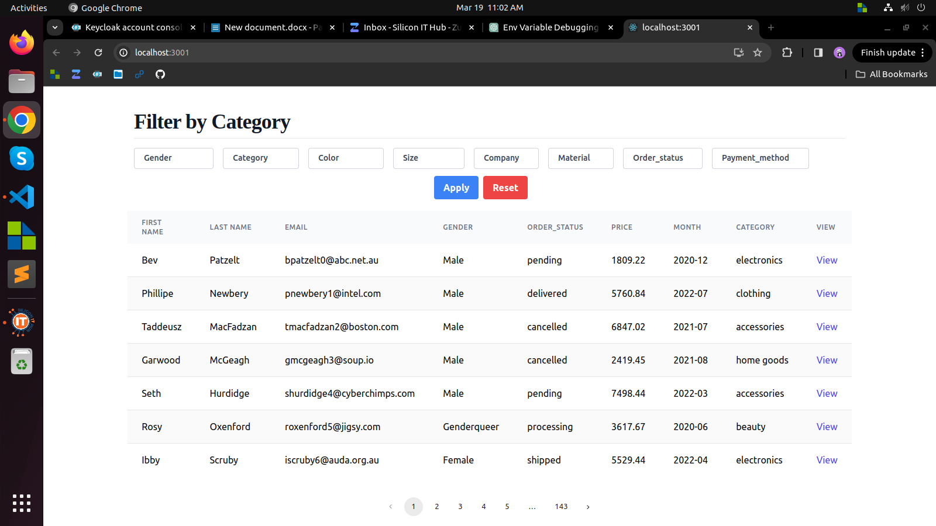

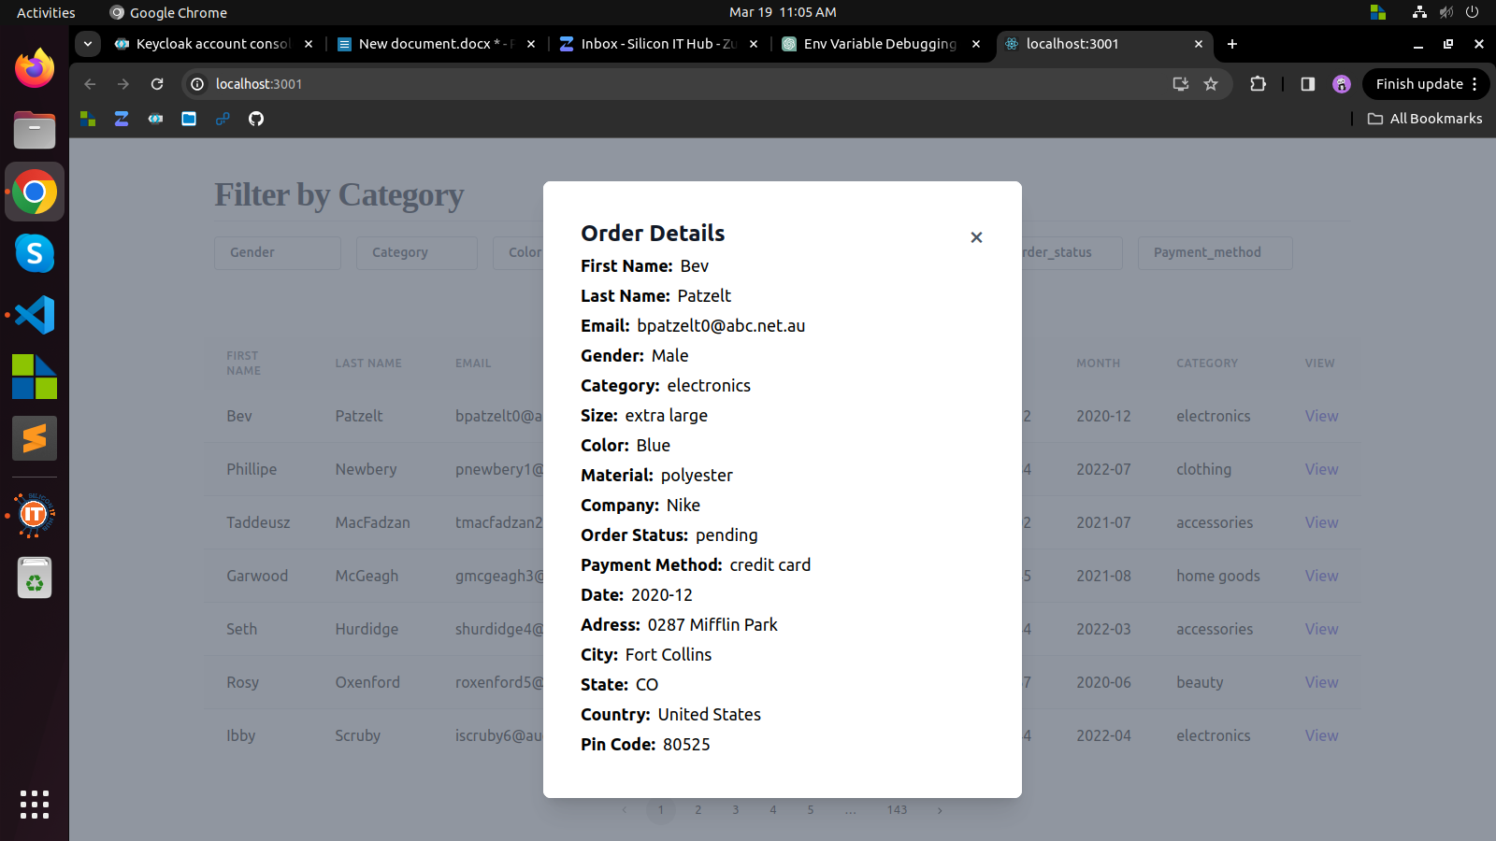

**Week 11**

**Objective:**

Week 11 was dedicated to gaining proficiency in React Redux, a state management library for React applications, and applying its concepts to develop practical projects. The primary focus was on understanding Redux core concepts, developing a Todo application, designing a dynamic dashboard, and exploring Redux middleware for handling asynchronous actions.

**Accomplishments:**

**Introduction to React Redux Core:**

* Explored Redux core concepts like actions, reducers, and the store for efficient state management.
* Embraced unidirectional data flow and immutability principles for stable state changes.

**Development of Todo Application:**

* Utilized React Redux for a fully functional Todo app, implementing Redux actions and reducers.
* Integrated Redux store to seamlessly manage global state and facilitate data flow between components.

**Integration of Redux Middleware:**

* Explored Redux middleware for handling asynchronous actions, integrating Redux Thunk for data fetching.
* Leveraged middleware for intercepting and processing actions, enhancing data manipulation capabilities.

**Conclusion:**

In Week 11, we mastered React Redux fundamentals, developed a Todo app, designed a dynamic dashboard, and explored Redux middleware. These achievements bolster our skills in state management and front-end development. Moving forward, we'll delve into advanced Redux concepts, optimize codebases, explore more Redux ecosystem tools, and apply Redux techniques in real-world projects.

**Screen Shots:**

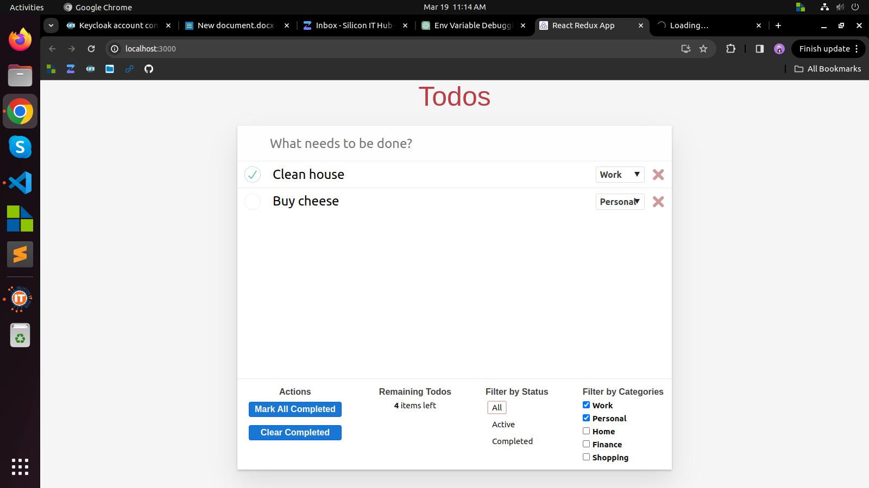

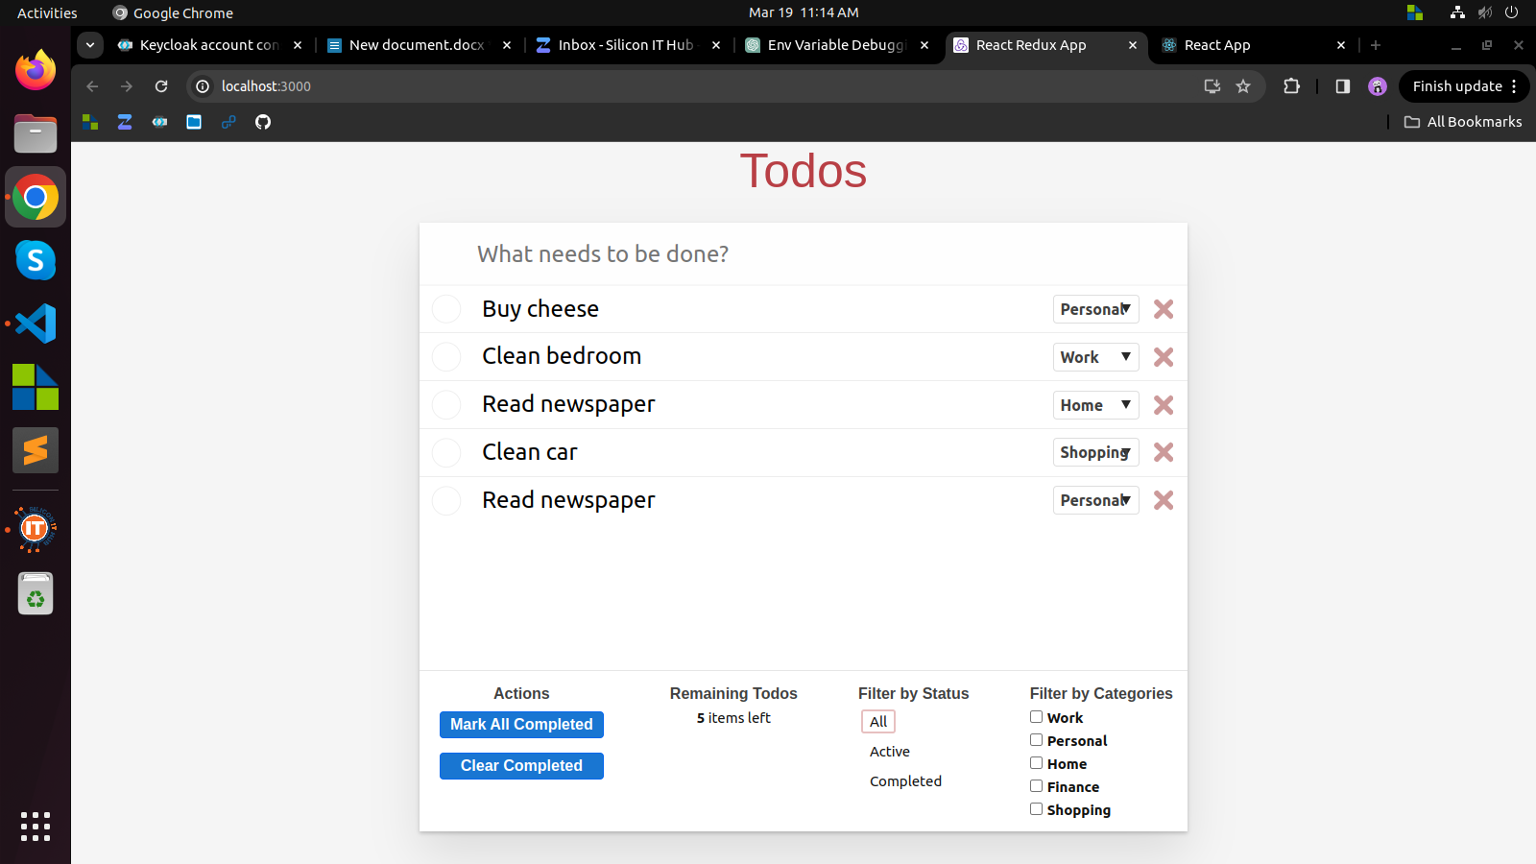

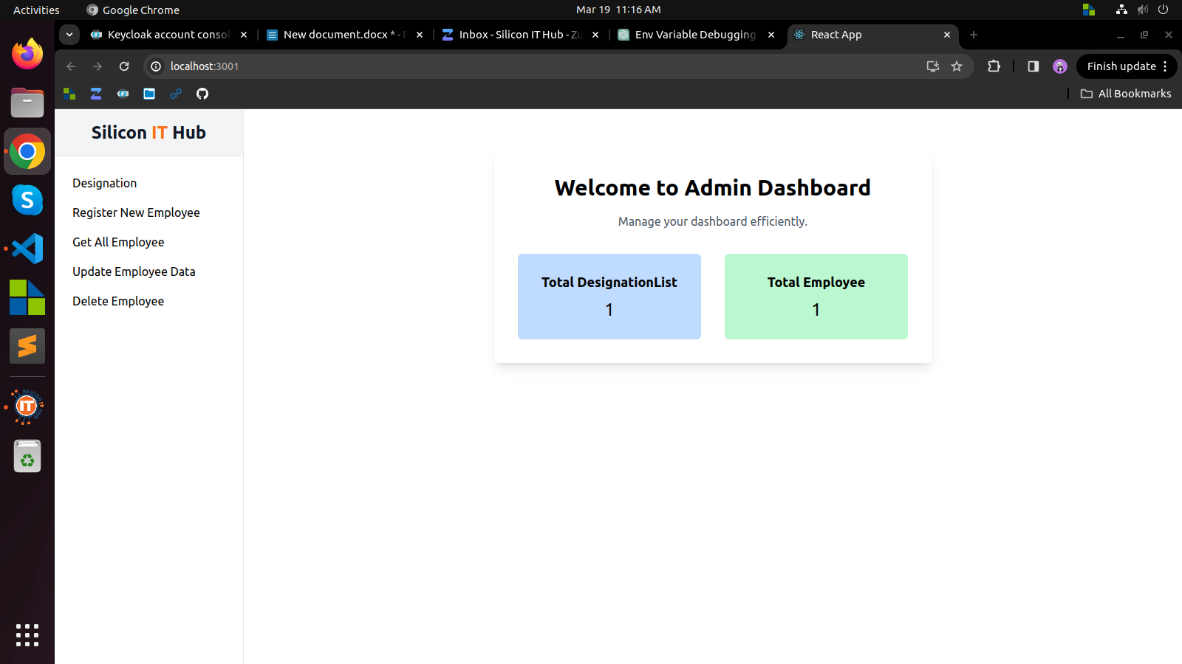

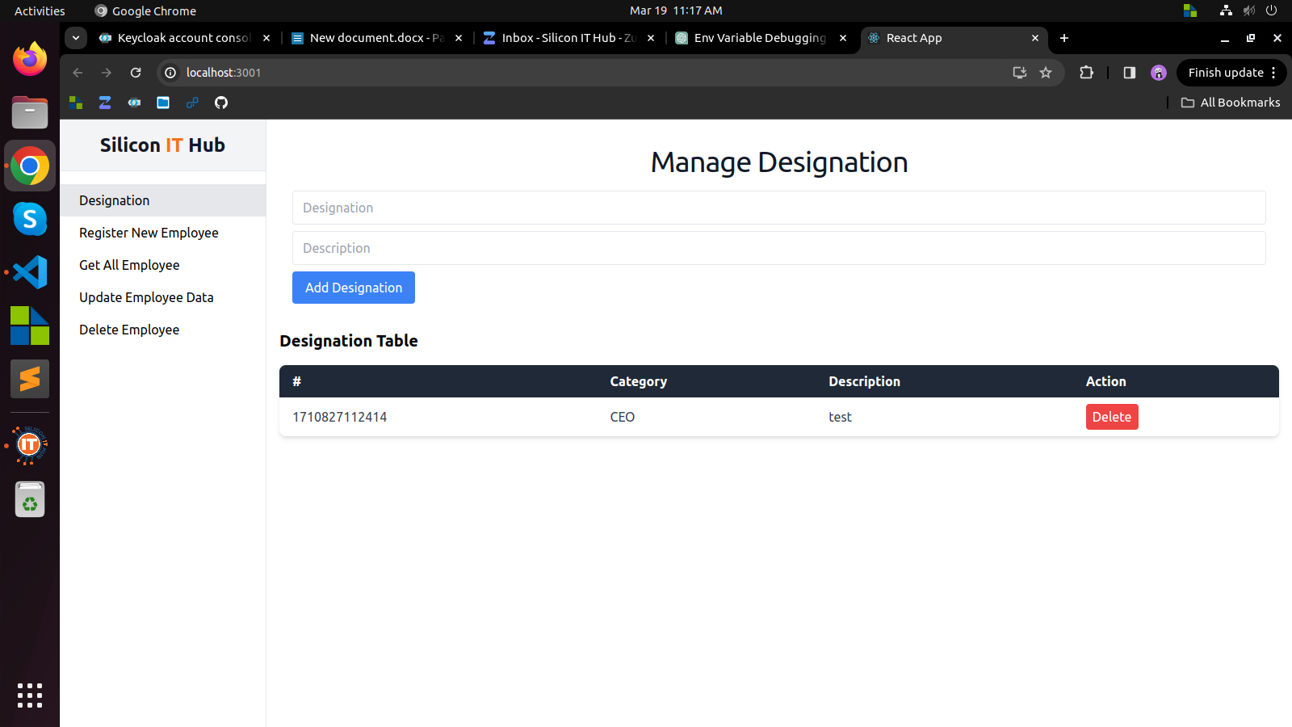

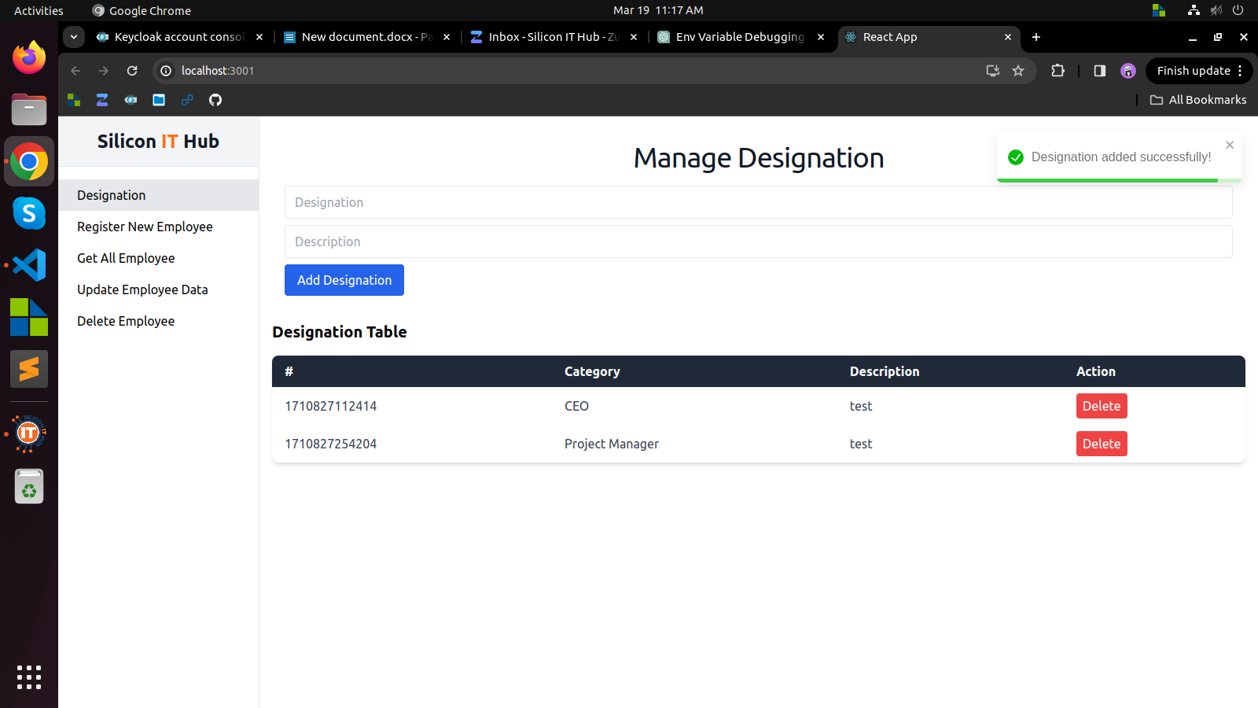

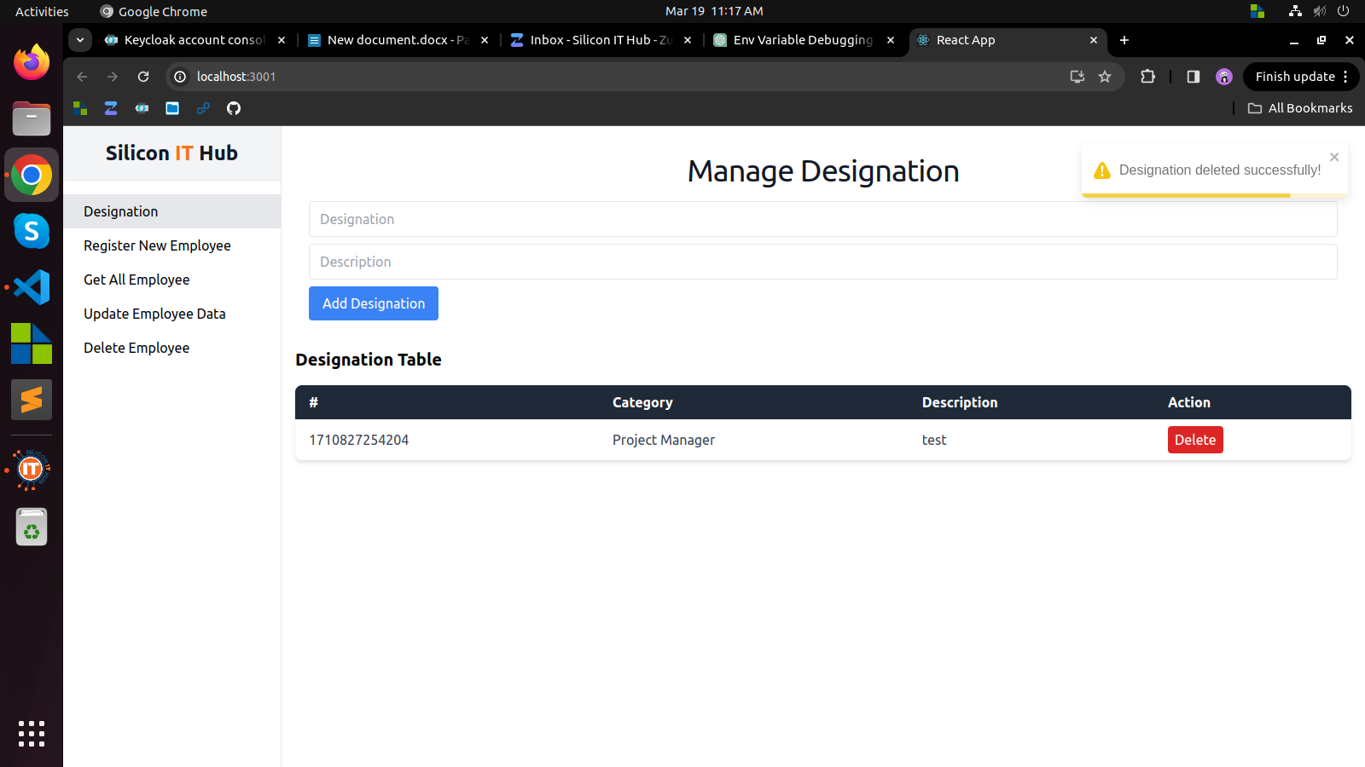

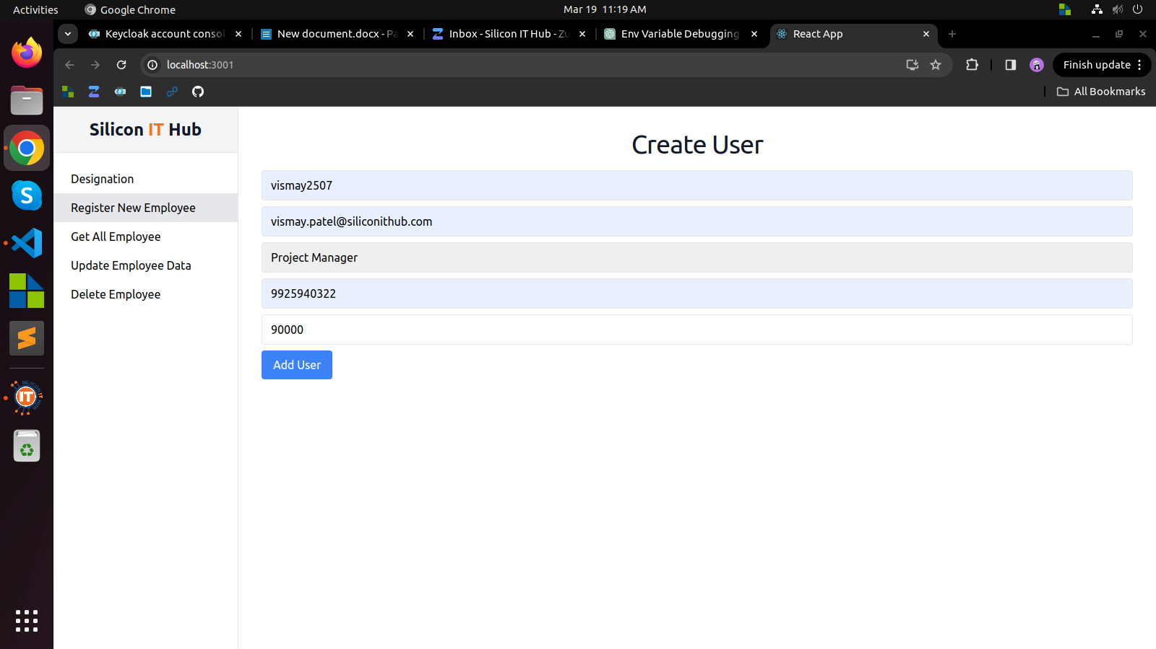

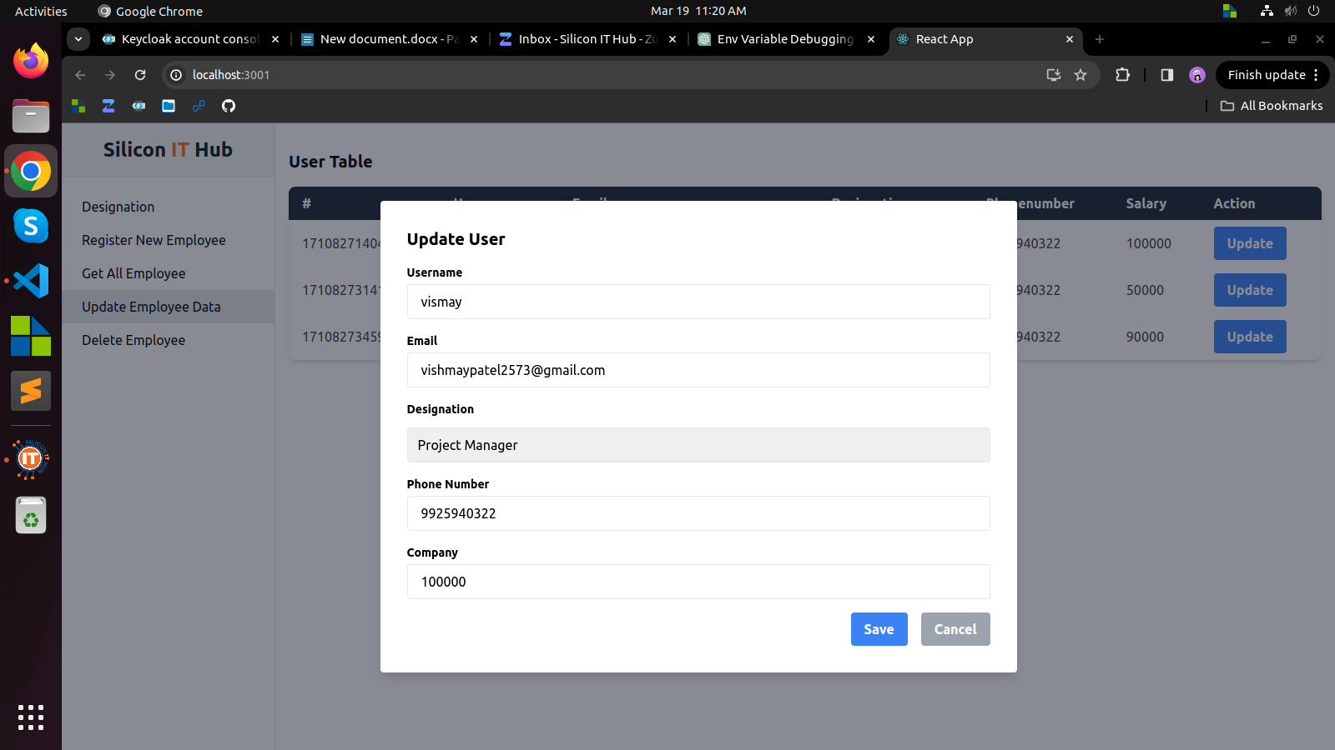

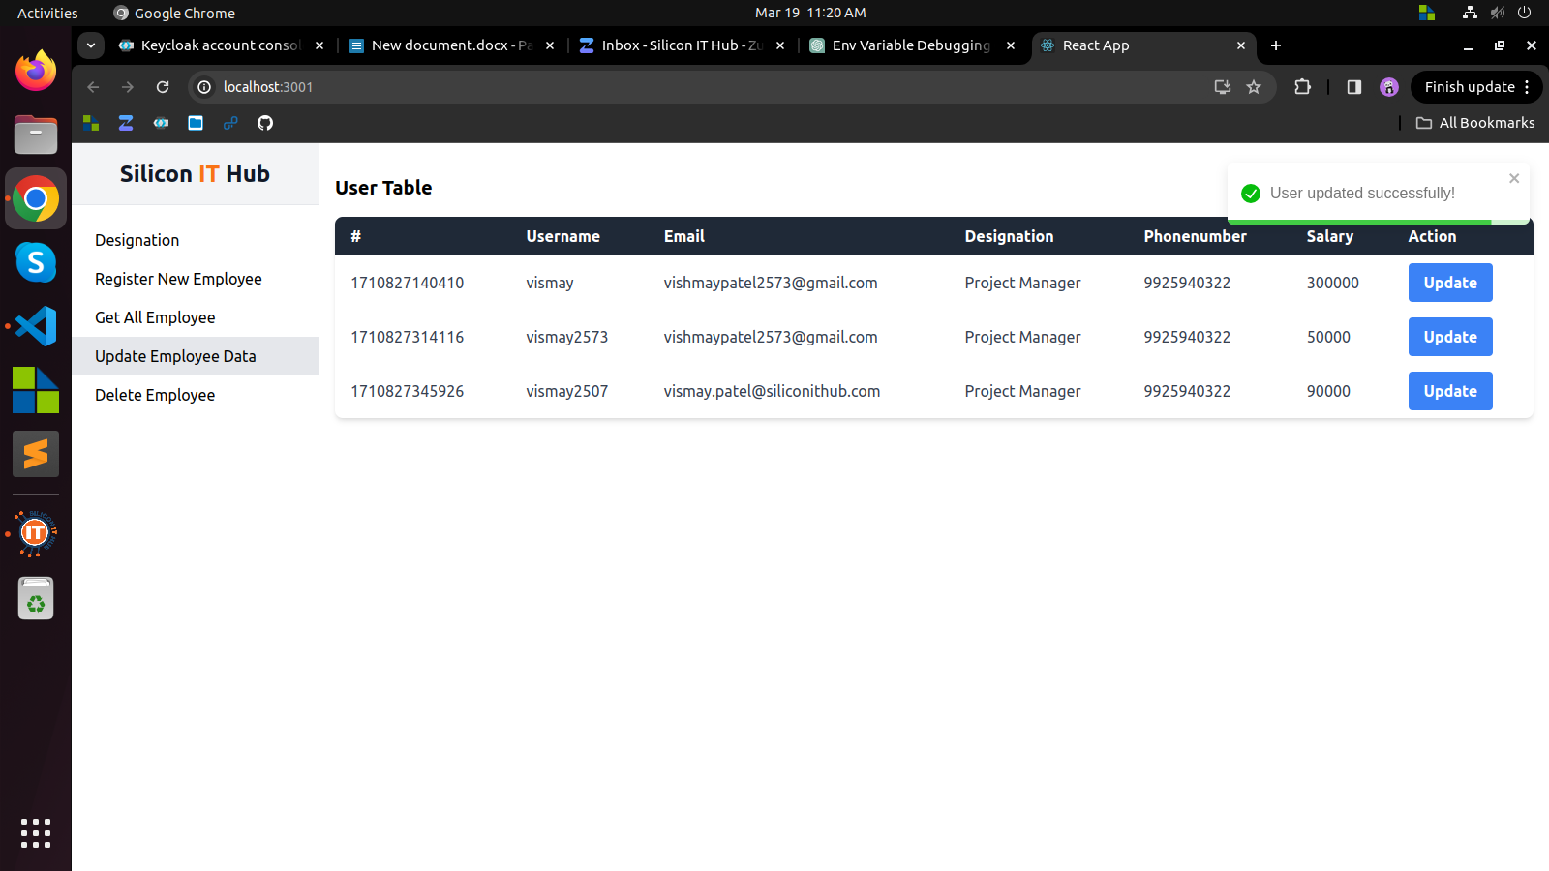

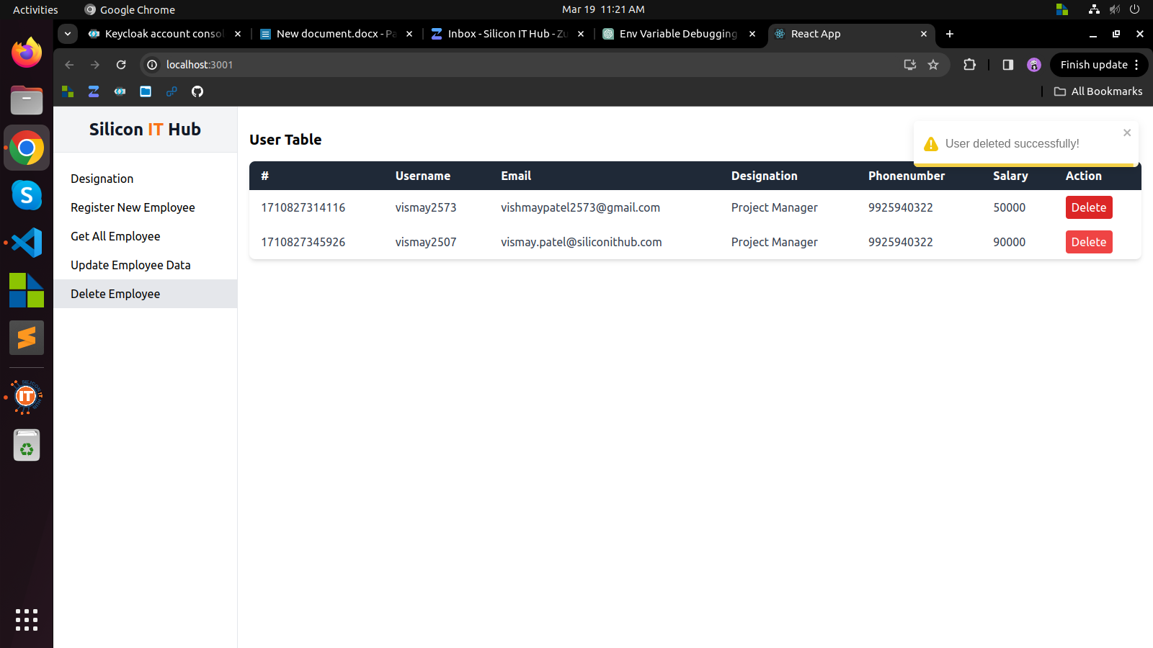

**Week 12**

**Objective:**

Week 12 aimed to master Redux Toolkit for streamlined state management and apply this knowledge to develop a dynamic social media application with enhanced user interaction.

**Accomplishments:**

**Learning Redux Toolkit:**

* Grasped core concepts including slices, reducers, actions, and middleware.
* Became proficient in utilizing Redux DevTools for debugging and monitoring state changes.

**Developing Social Media App:**

* Created a dynamic social media application with features like posting, reactions, notifications, and real-time updates.
* Leveraged Redux Toolkit's simplified syntax and built-in utilities for efficient state handling and consistency across components.

**Enhancing User Interaction:**

* Implemented interactive features such as posting, reactions, and notifications to foster active user participation.
* Utilized real-time updates via Socket.IO for instant feedback on interactions and content changes.

**Conclusion:**

In Week 12, we successfully mastered Redux Toolkit and applied it to develop a dynamic social media application with enhanced user interaction. By leveraging Redux Toolkit's simplified syntax and built-in utilities, we ensured efficient state handling and consistency across components. Moving forward, we'll conduct testing and debugging, explore advanced Redux Toolkit features, and iterate based on user feedback to enhance the application's design and functionality.

**Screen Shots:**

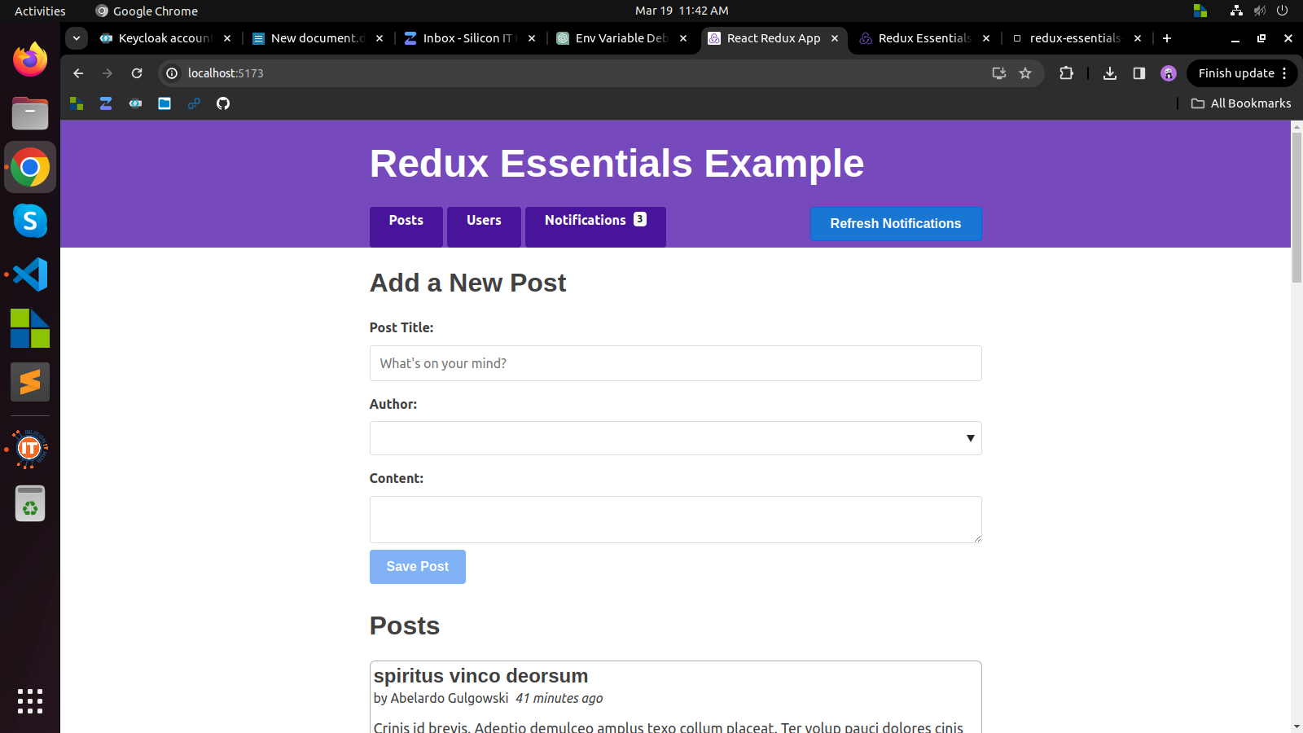

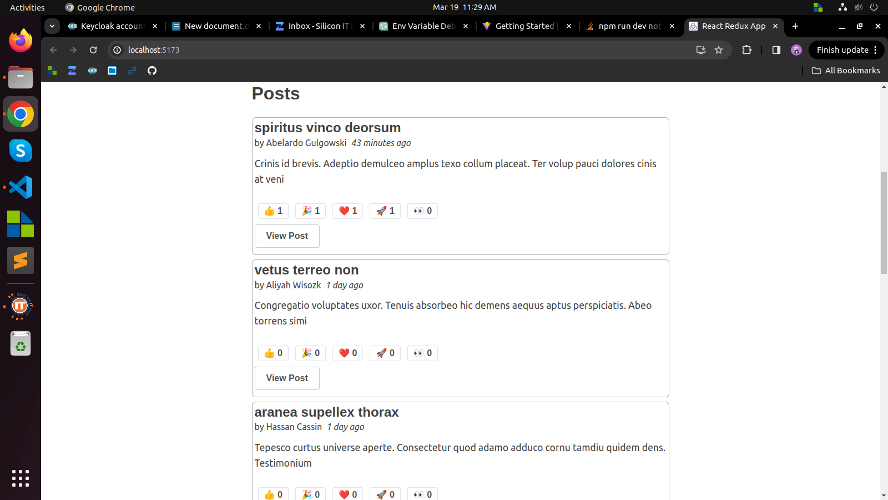

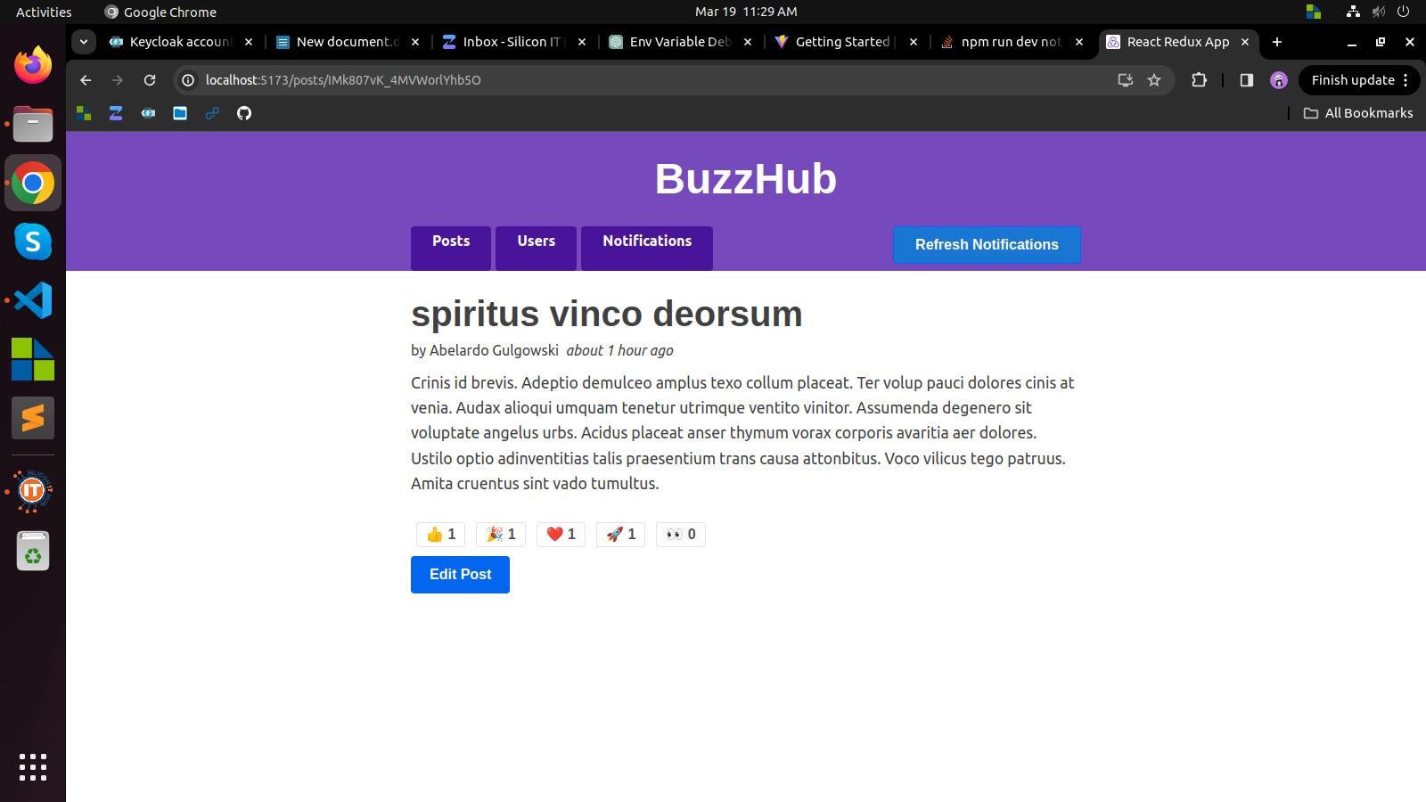

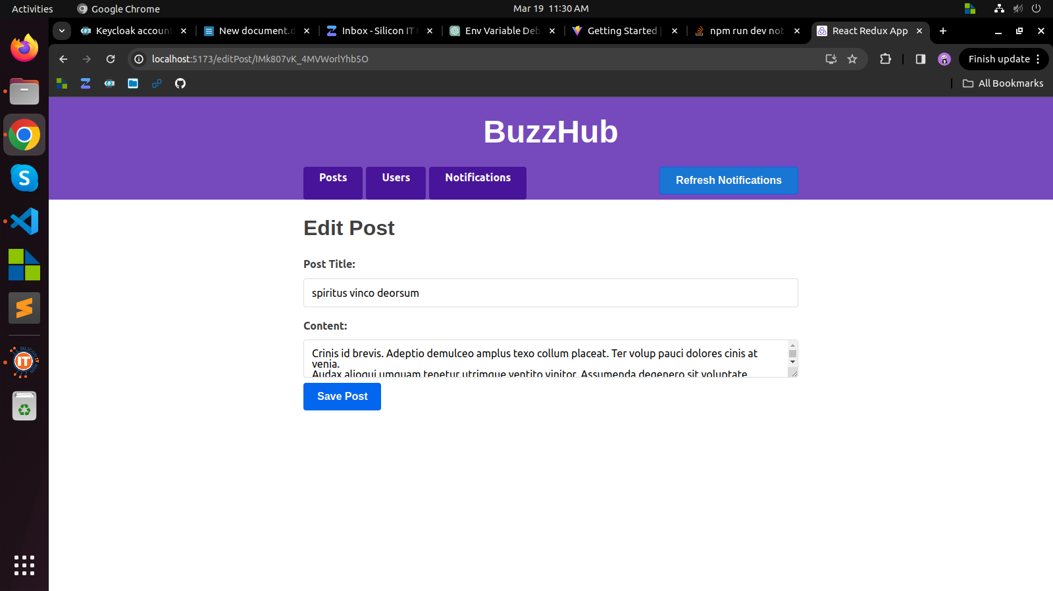

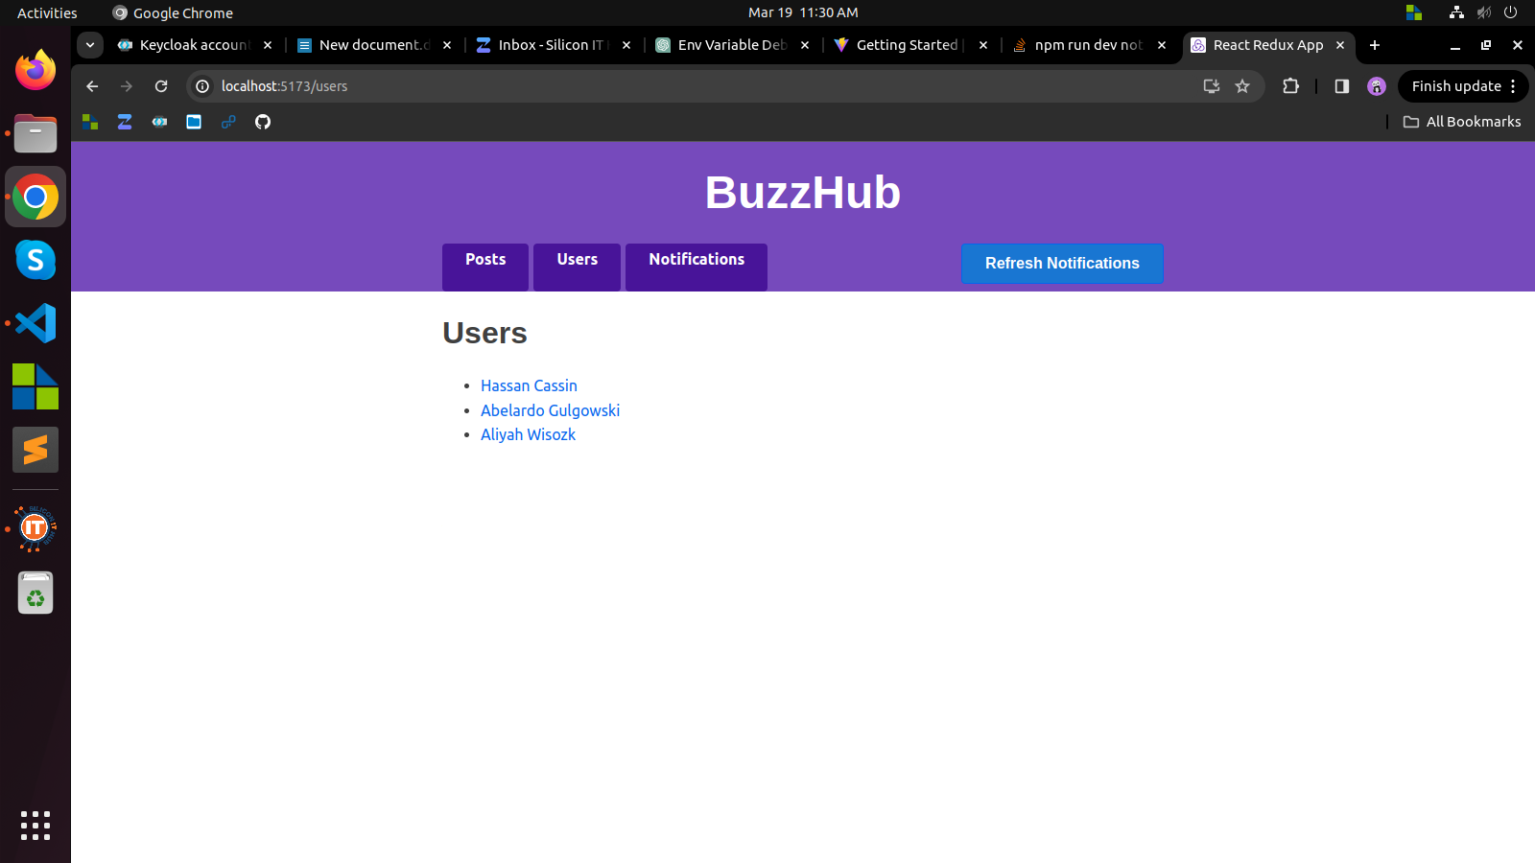

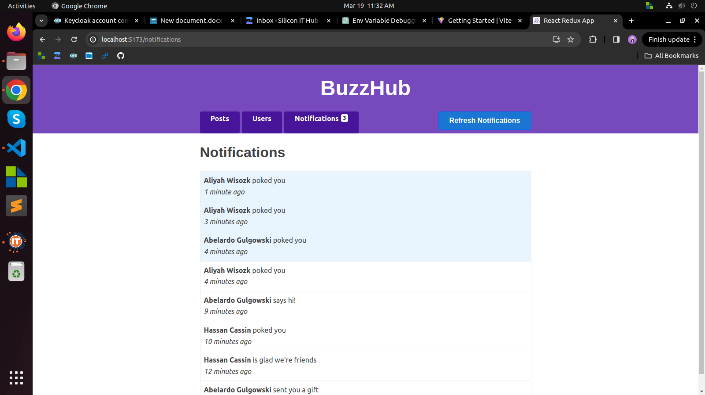

**Week 13**

**Objective:**

The objective of this week was to further develop and refine the Budget Buddy expense tracker application and complete the creation of my professional portfolio website. This involved implementing key features in Budget Buddy to enhance user experience and functionality, as well as ensuring my portfolio effectively showcases my skills, projects, and experience.

**Accomplishments:**

**Budget Buddy App Development:**

* Implemented "Add Cash In" and "Cash Out" functionality, allowing users to accurately track their financial transactions.
* Enhanced management of payment categories and methods to provide users with better organization and control over their expenses.
* Integrated a report generation feature, enabling users to analyze their expenditure patterns and make informed financial decisions.

**Portfolio Website Creation:**

* Designed and developed my professional portfolio website, featuring sections such as "About Me," "Blogs," "Projects," "Resume," and "Contact."
* Crafted engaging content for each section to effectively communicate my skills, interests, and achievements.
* Ensured seamless navigation and user-friendly interface to provide visitors with a pleasant browsing experience.

**Conclusion:**

This week was highly productive and rewarding as I successfully achieved the set objectives. The development of Budget Buddy has progressed significantly, with essential features added to enhance its usability and value to users. Additionally, the completion of my portfolio website marks an important milestone in establishing my online presence and showcasing my capabilities to potential employers or collaborators. Looking ahead, I am excited to continue refining both projects and exploring opportunities for further growth and innovation.

**Screen shots:**

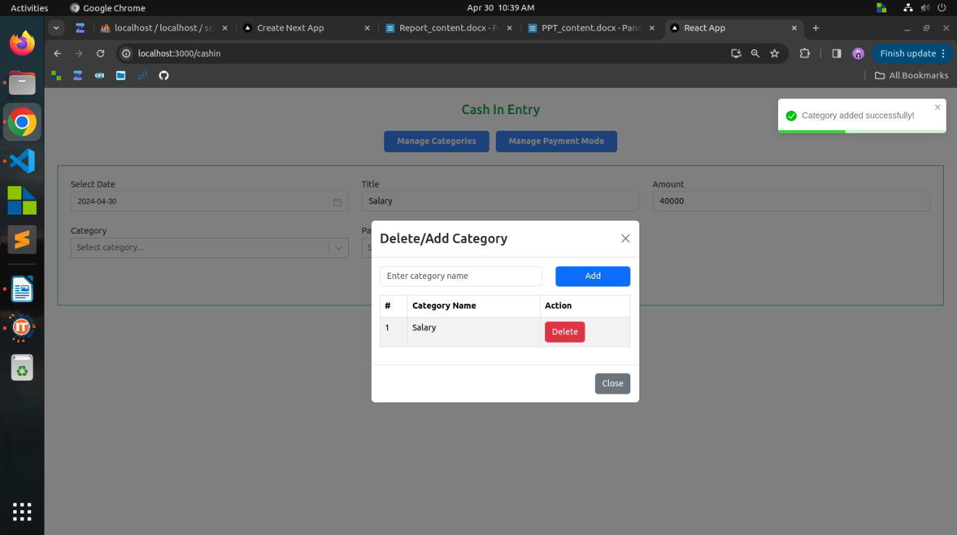

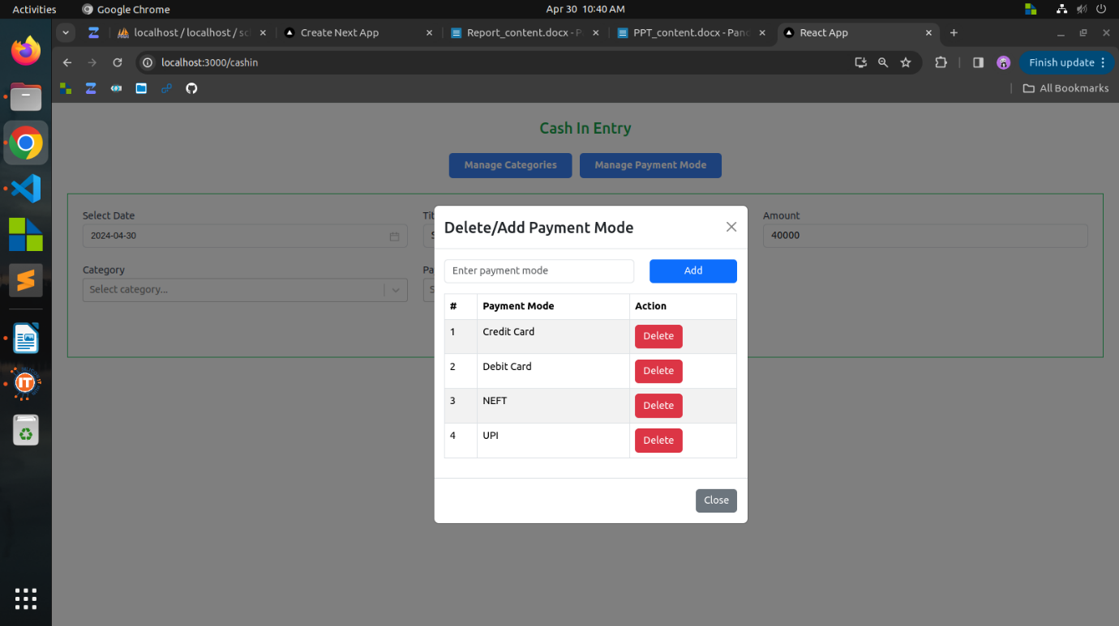

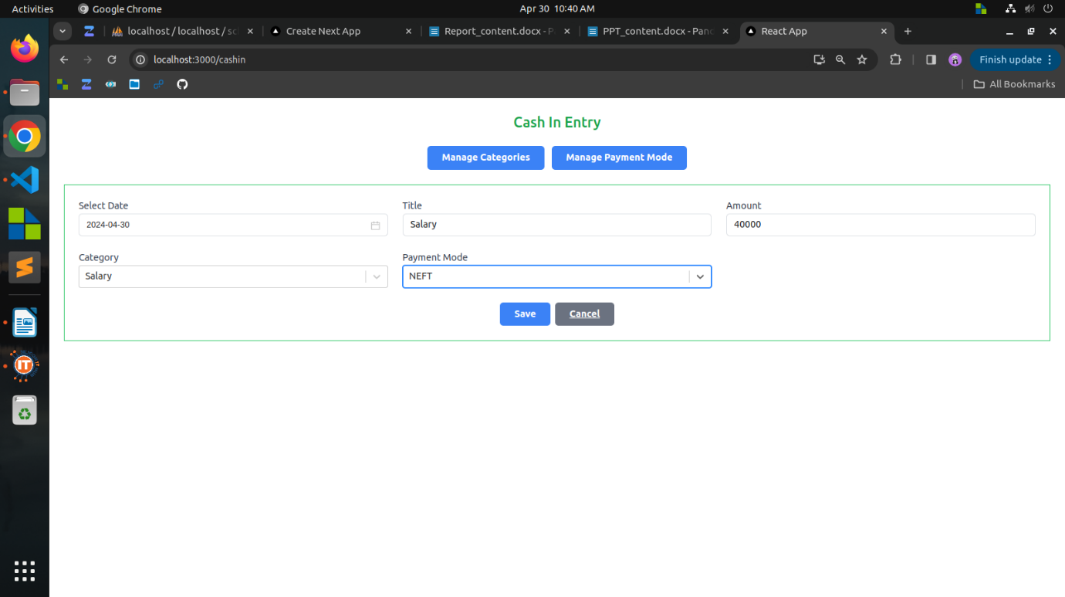

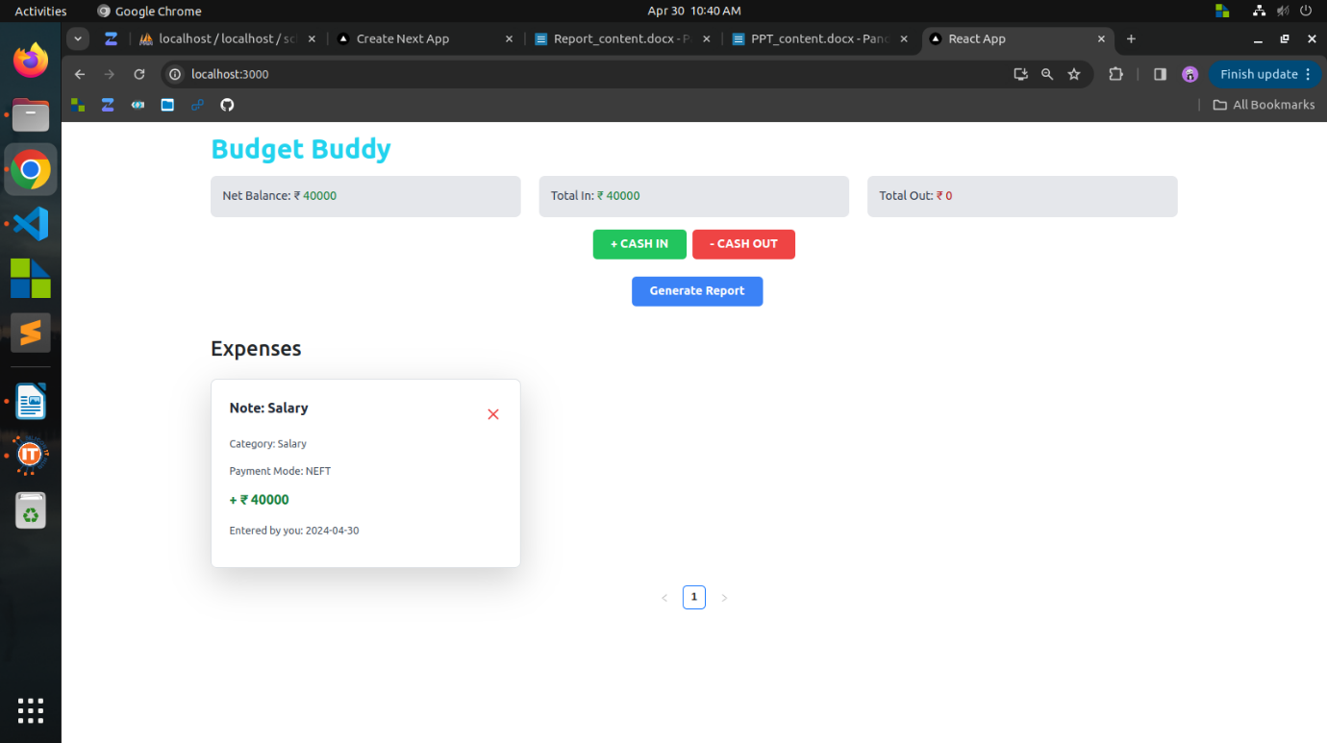

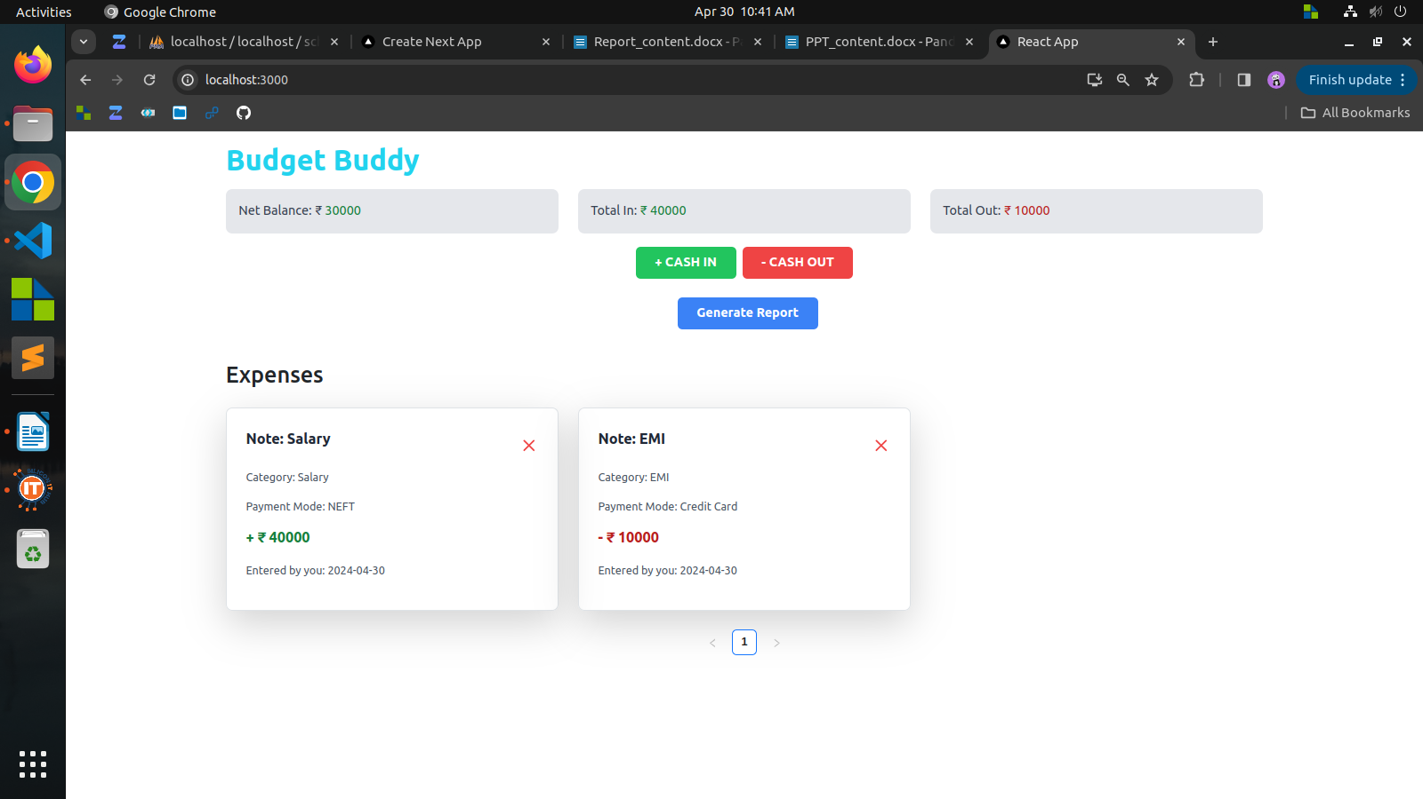

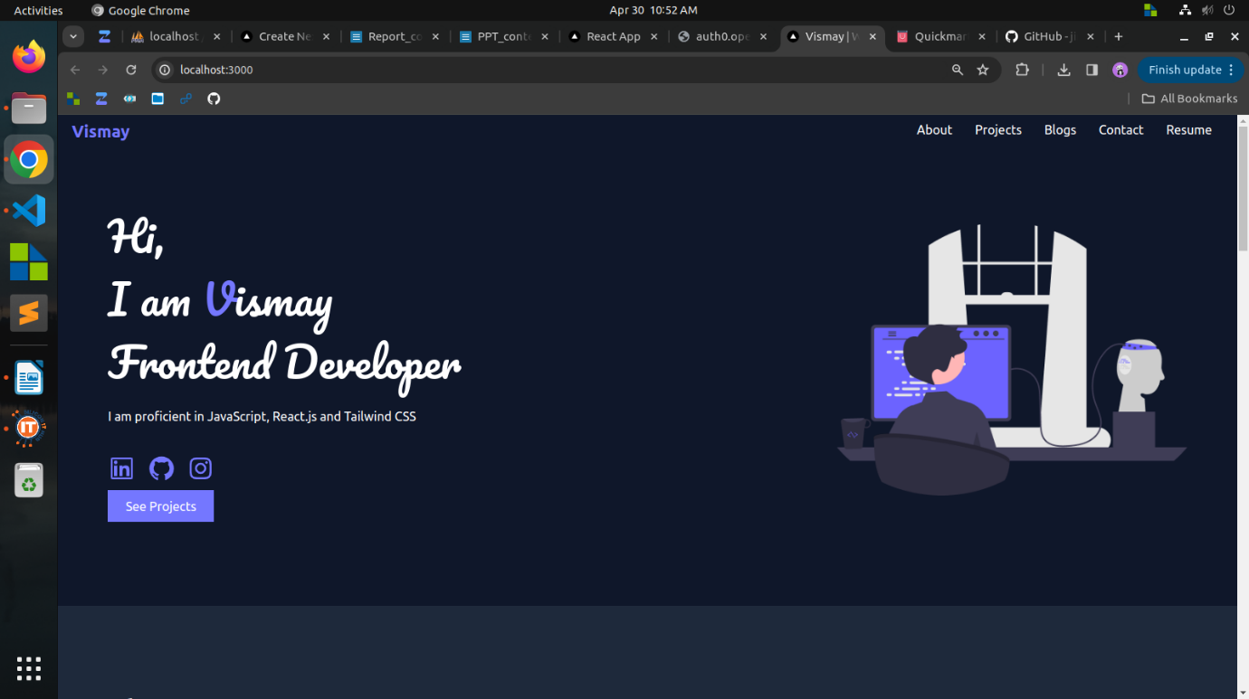

**Week 14**

**Objective:**

The objective of Week 14 was to develop and launch the CineSwap movie tracker application, leveraging React and the TMDB API to create a platform where users can explore and trade movies and TV shows. Additionally, I aimed to initiate my learning journey in Next.js, a popular React framework, to expand my skill set and explore new possibilities in web development.

**Accomplishments:**

**CineSwap Development:**

* Created "CineSwap: Your Ultimate Movie & TV Show Exchange" application using React and integrated it with the TMDB API.
* Implemented browsing functionality, allowing users to discover a wide range of movies and TV series available for trading.
* Incorporated features to display essential information such as ratings, synopsis, release dates, and trailers, providing users with comprehensive details to make informed decisions.

**Learning Next.js:**

* Initiated the learning process for Next.js, a powerful React framework for building server-side rendered and statically generated web applications.
* Covered basics such as setting up a Next.js project, understanding routing, and exploring key concepts like server-side rendering and data fetching.
* Experimented with Next.js features to gain practical experience and insight into its advantages and applications in web development.

**Conclusion:**

Significant progress was made in project development and skill enhancement. CineSwap, a platform for movie and TV show trading, was successfully created and launched, offering valuable features and information to users. Additionally, starting to learn Next.js presents exciting opportunities to explore advanced web development techniques for creating dynamic and efficient web applications. Looking forward to refining CineSwap and deepening understanding of Next.js for continued growth and innovation as a developer.

**Screen shots:**

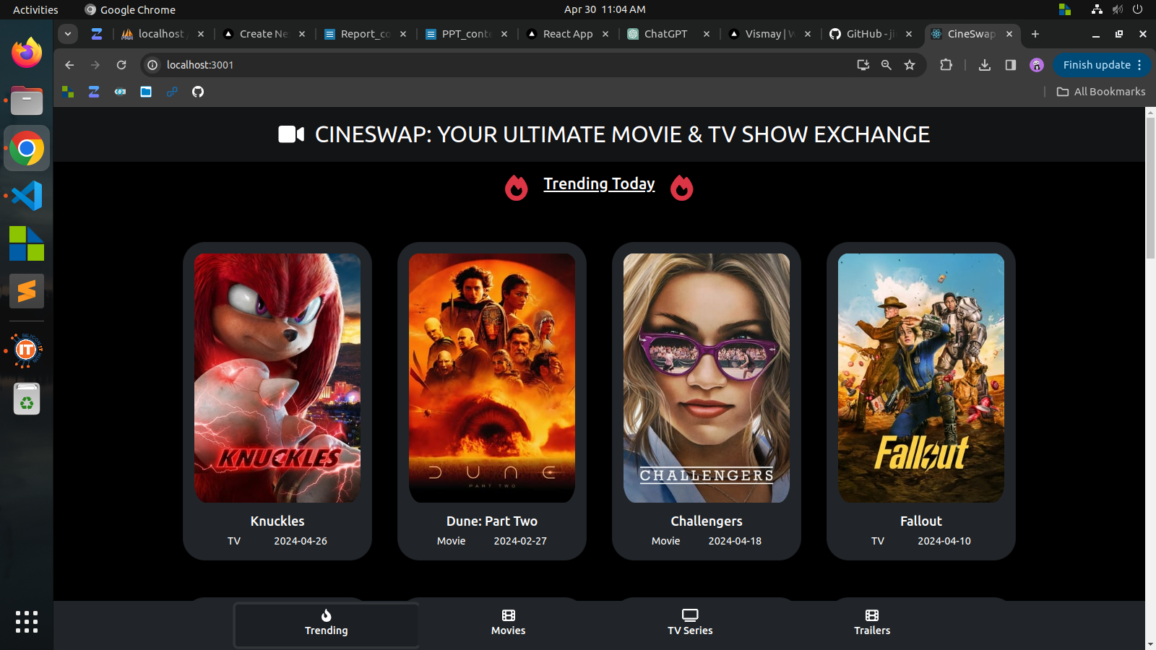

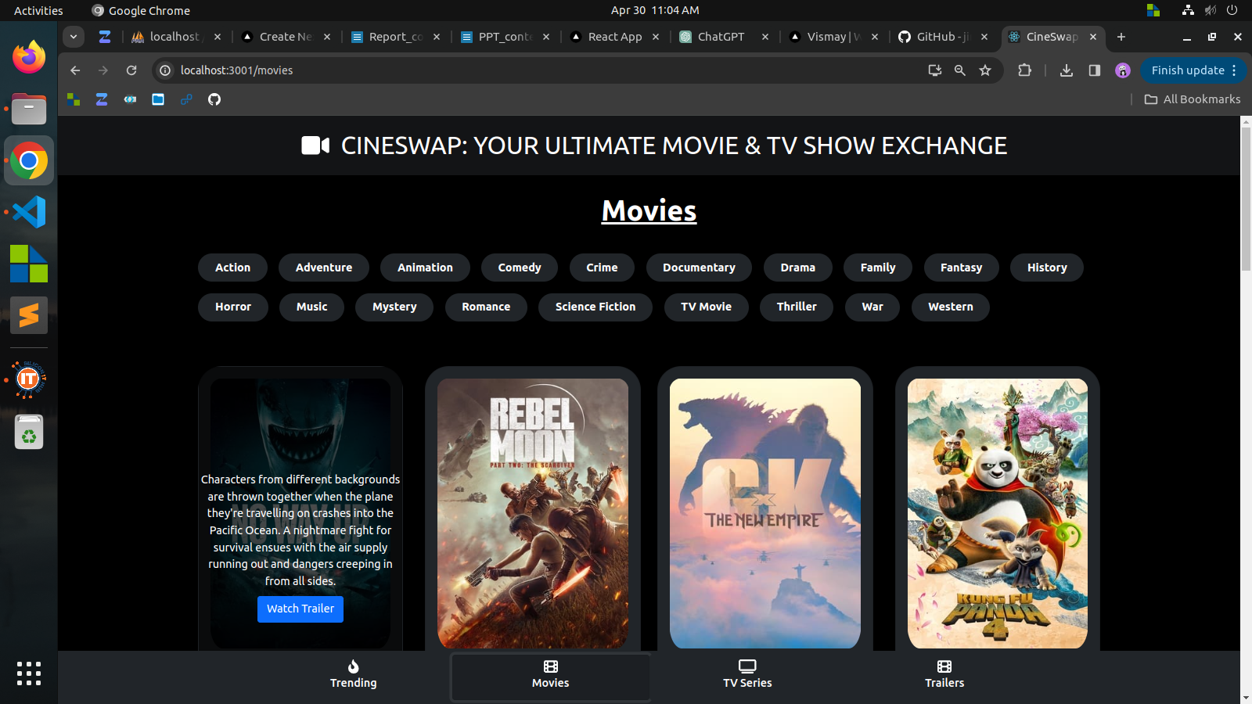

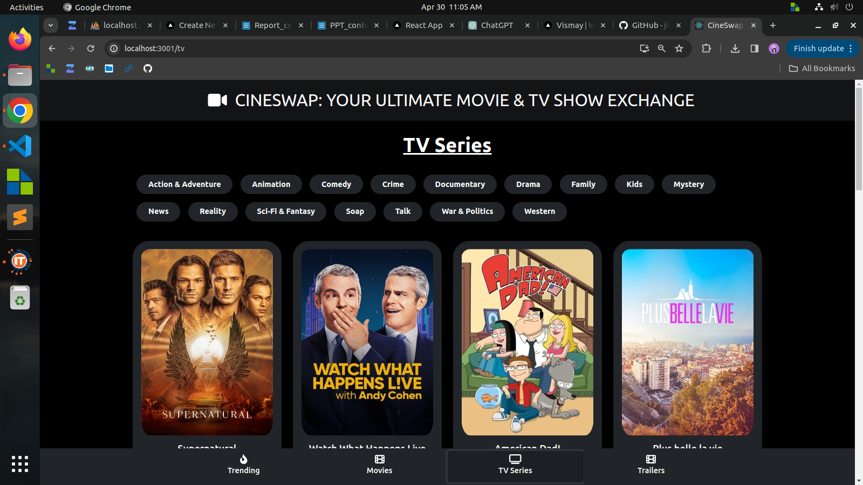

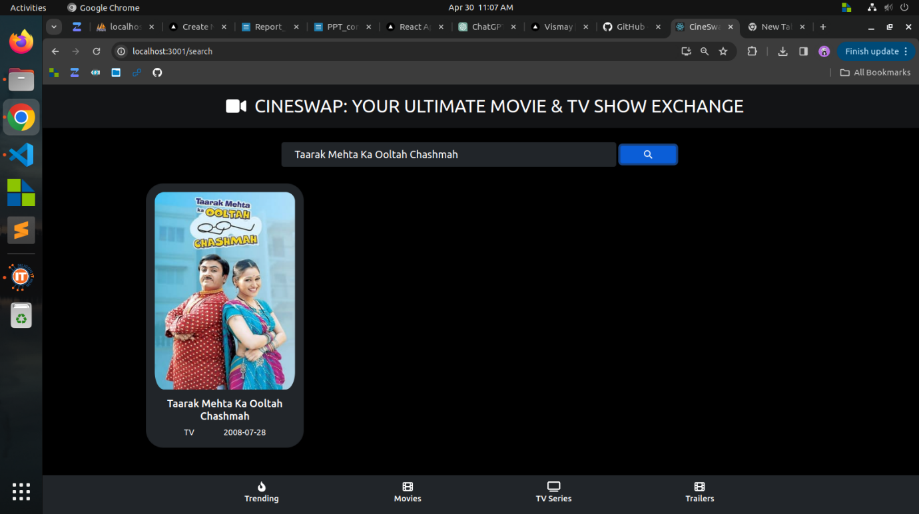

**Week 15**

**Objective:**

Mastered authentication using Appwrite and Nodemailer, integrated MongoDB for database management, and solidified Next.js skills by developing an advanced dashboard interface.

**Accomplishments:**

**Appwrite Authentication:**

* Implemented secure user authentication via Appwrite, enabling registration, login, and profile management.
* Ensured robust security, including password encryption and user verification, for data protection.

**Nodemailer Integration:**

* Integrated Nodemailer for sending verification emails and password recovery securely.
* Implemented secure email handling practices to uphold user data privacy.

**MongoDB Database Integration:**

* Successfully integrated MongoDB for efficient data storage and retrieval.
* Used MongoDB to manage user authentication data and profiles securely.

**Next.js Dashboard Development:**

* Developed a comprehensive dashboard interface with Next.js, incorporating advanced features and best practices.
* Implemented styling techniques, optimizations, and error handling to enhance user experience and application performance

**Conclusion:**

Week 15's focus on mastering authentication, integrating MongoDB, and advancing Next.js skills marks significant progress in my web development journey, empowering me to build secure and efficient applications.

**Screen shots:**

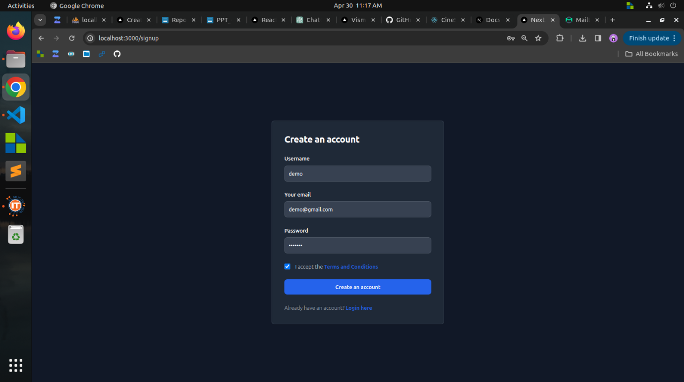

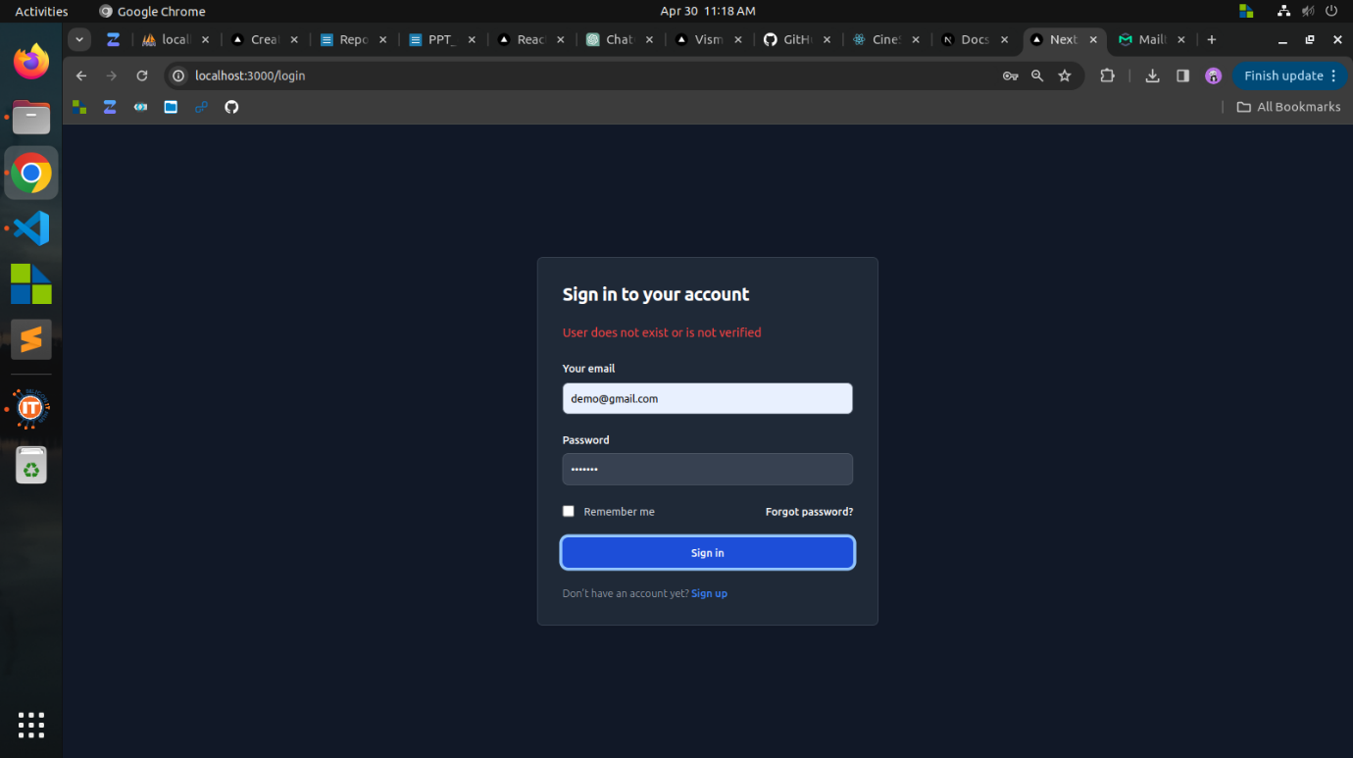

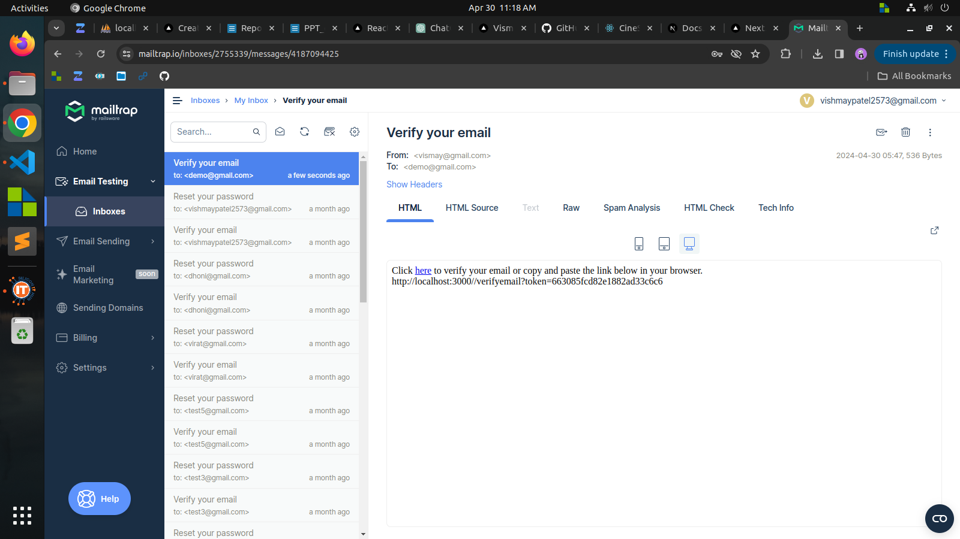

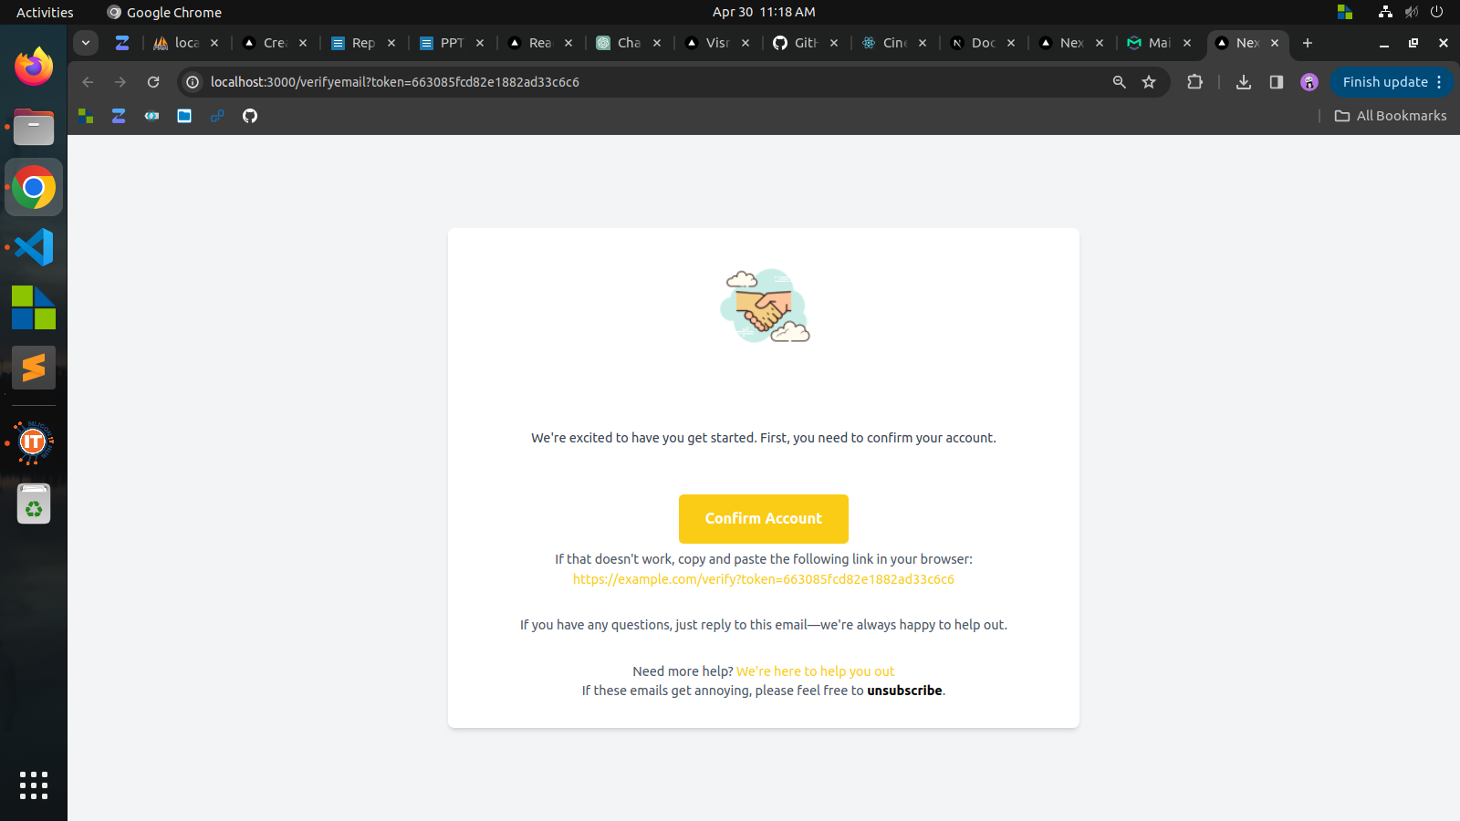

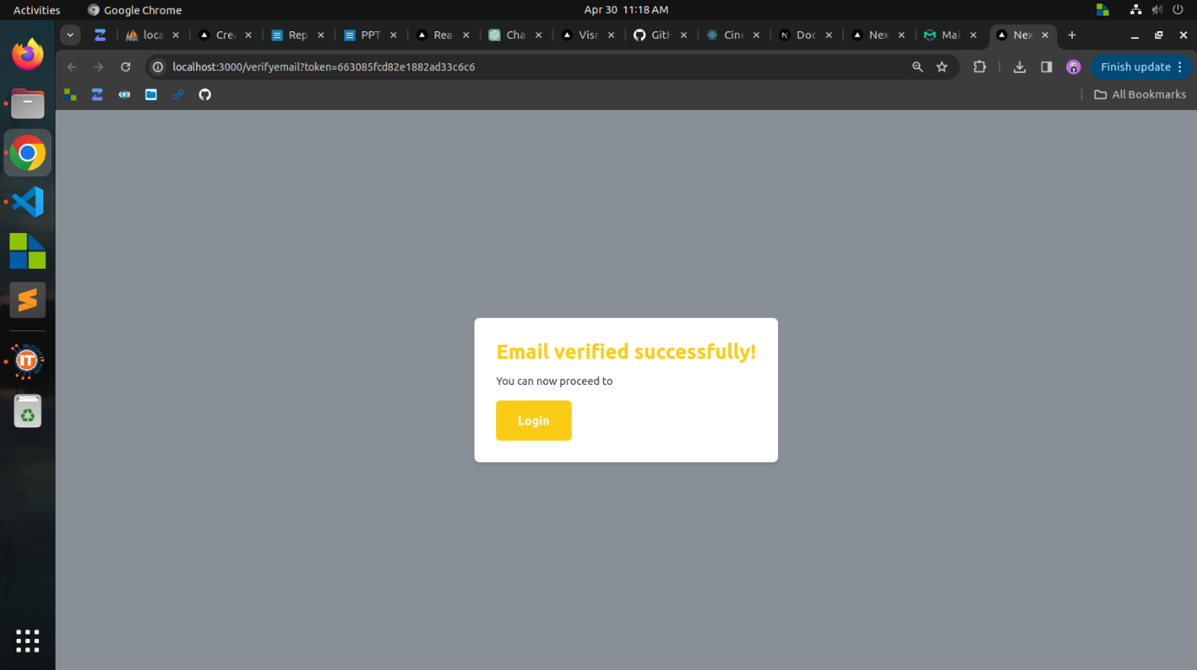

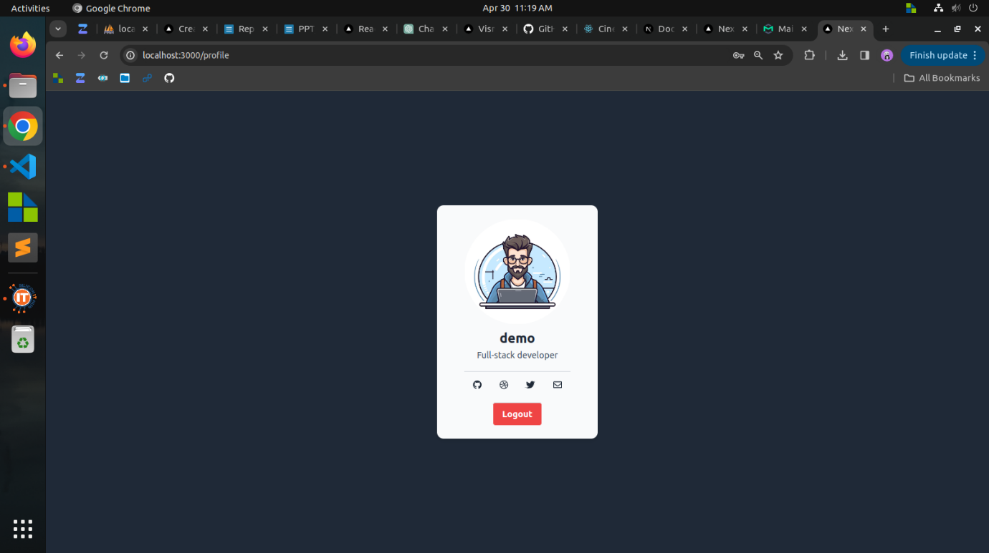

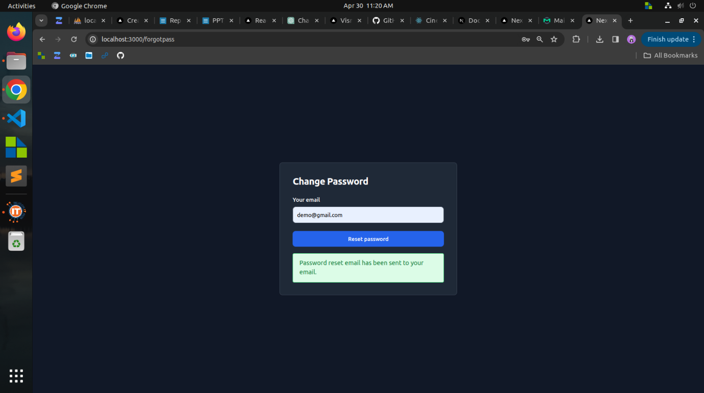

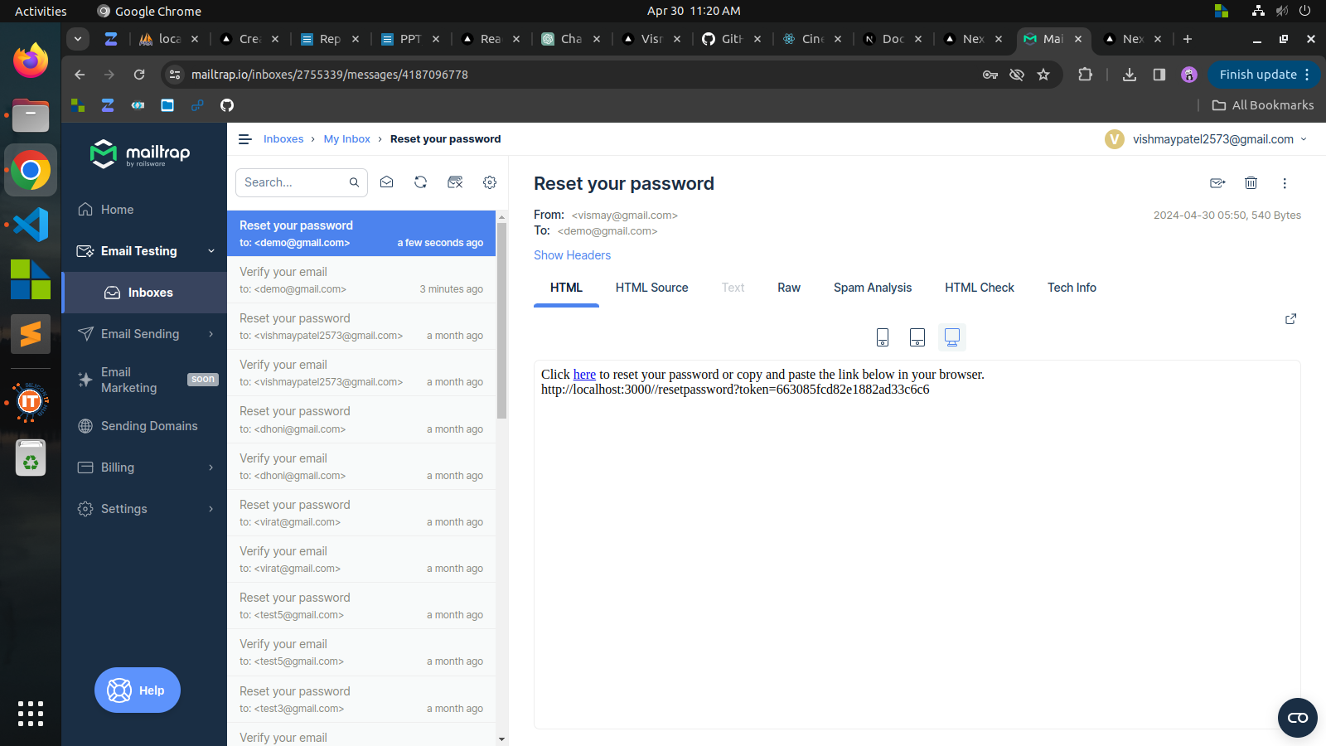

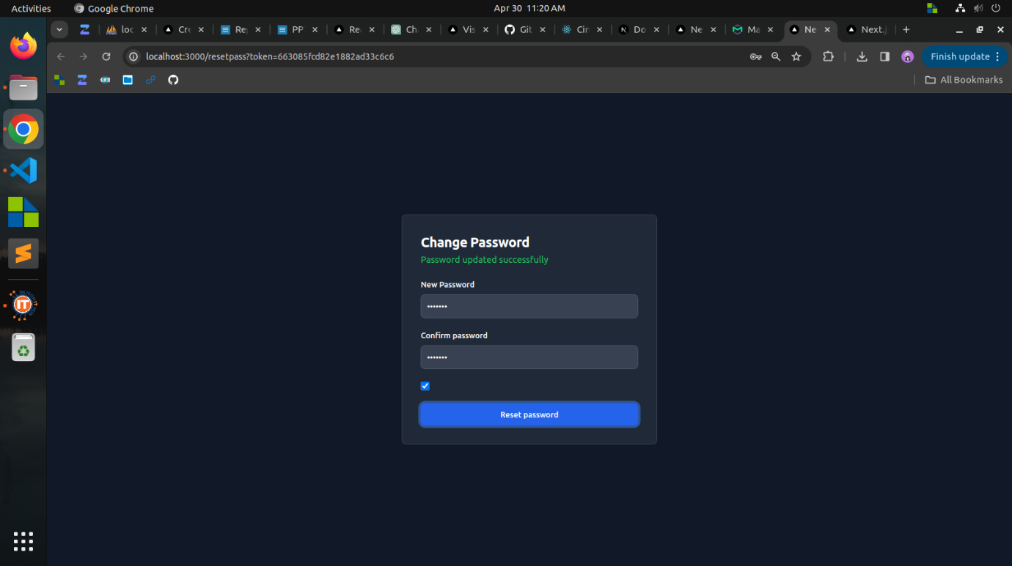

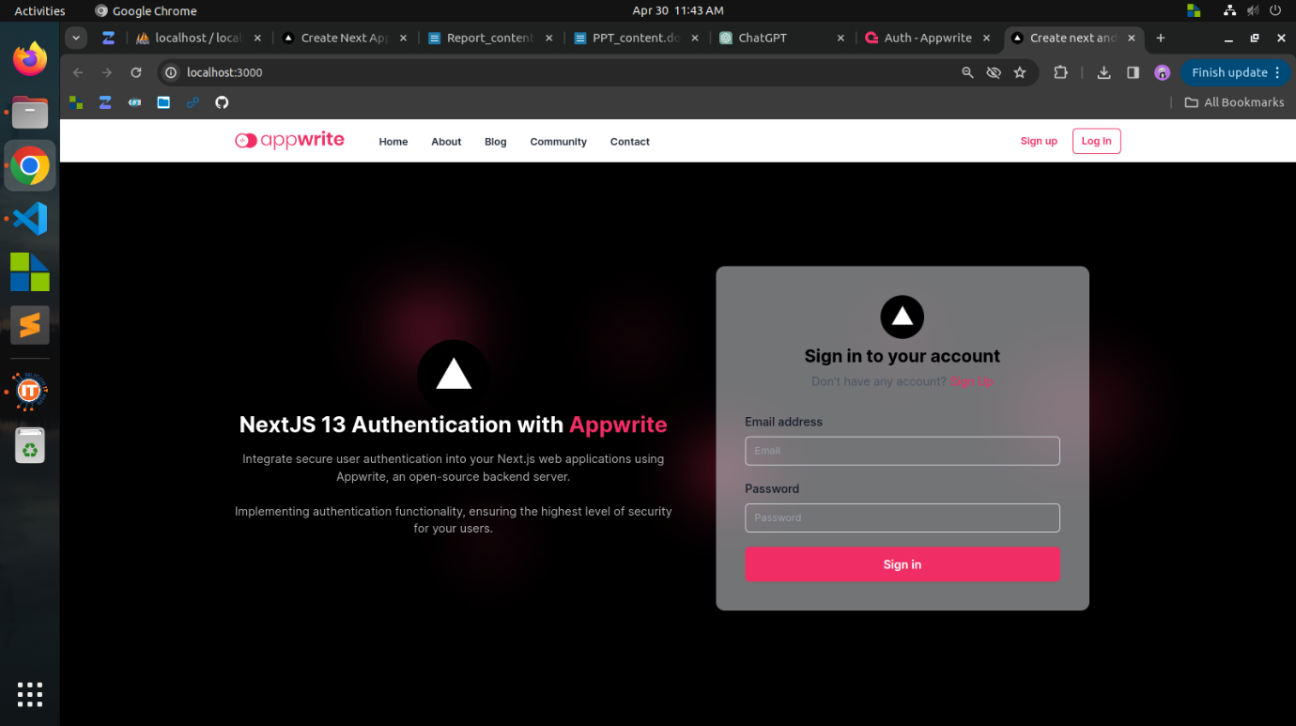

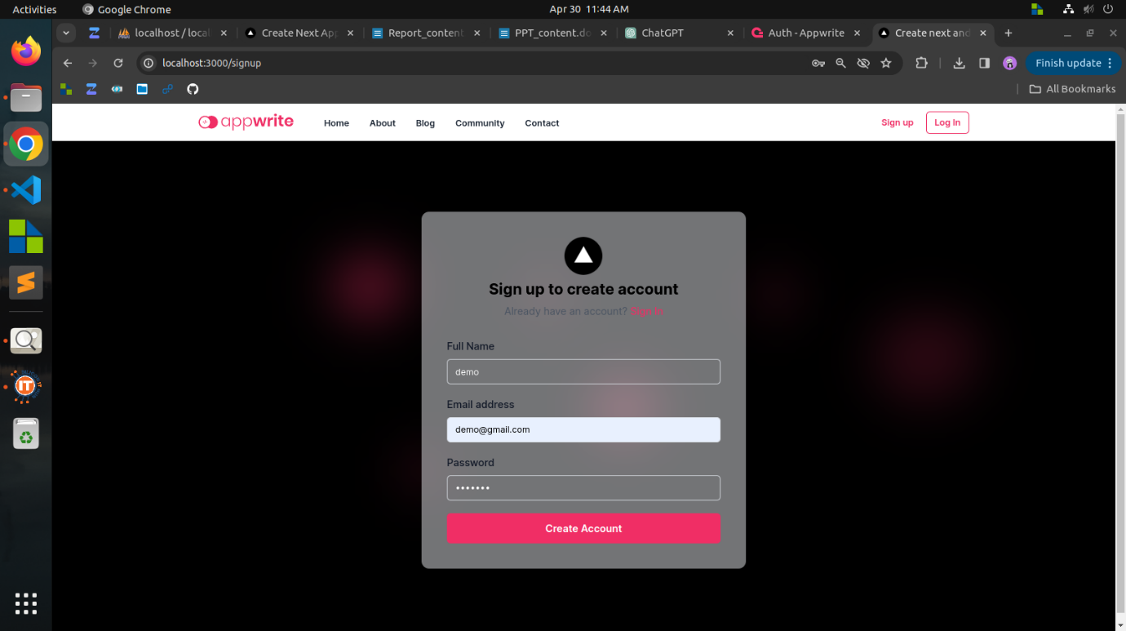

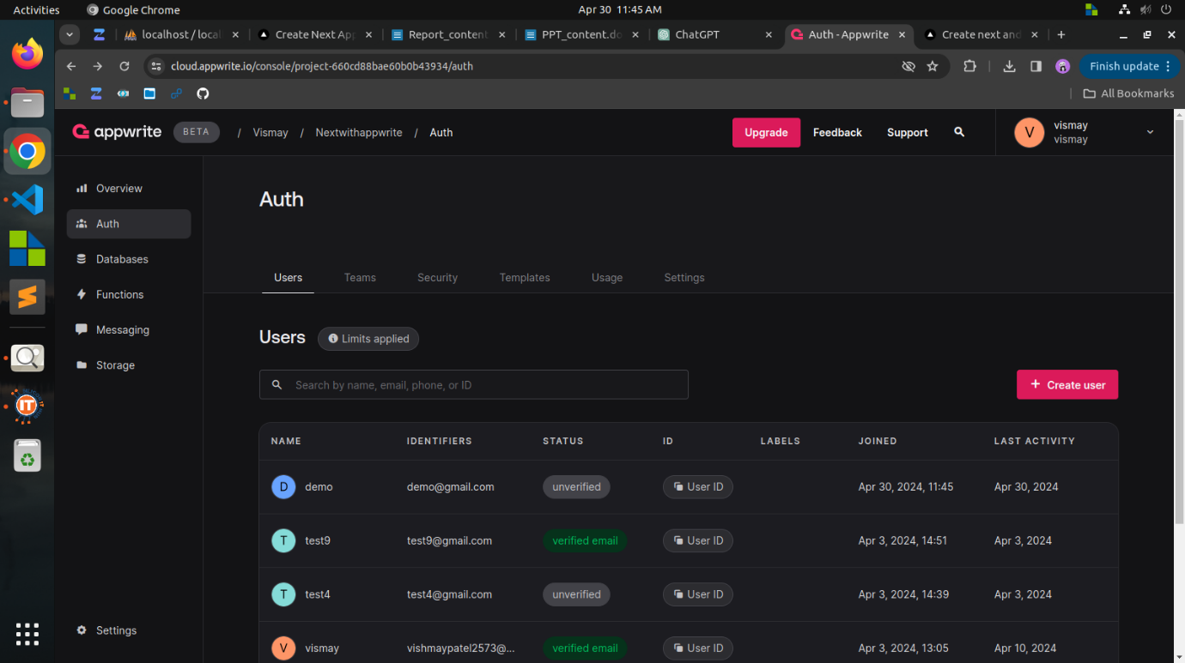

**Week 16**

**Objective:**

In Week 16, TechTonic was built using Next.js and PHPMyAdmin. It features user registration and verification, with admin and regular user roles. Dashboards are tailored for each role, including functionalities for creating, viewing, and reacting to blogs. Users have dynamic profiles and personalized navigation bars. Admins can edit posts and view reactions.

**Accomplishments:**

**TechTonic Blog Site Development:**

* Developed the TechTonic blog site using Next.js for frontend development and PHPMyAdmin for database management.
* Implemented user authentication functionalities, including login and signup features. User verification was required before accessing the site.
* Created various user roles, including admin and regular user, with separate dashboards tailored to their specific needs and permissions.
* Designed the main page to display blogs dynamically, allowing users to create and view posts. Users could also add reactions to posts.
* Implemented dynamic user profiles, ensuring each user had a personalized experience based on their preferences and activity.
* Configured the navigation bar to adapt to the user's role, displaying different options and functionalities accordingly.
* Provided admin users with additional capabilities such as editing their posts and viewing reactions from other users.
* Included about and contact pages to provide additional information about the site and facilitate communication with users.
* Granted superadmin access to oversee and manage all aspects of the site's functionality and content.

**Conclusion:**

Week 16 achieved the launch of TechTonic, a dynamic blog platform enabling content creation, sharing, and interaction. Its user authentication, role-based access, and personalized dashboards ensure an engaging experience, with ongoing efforts to enhance its value.

**Screen shots:**

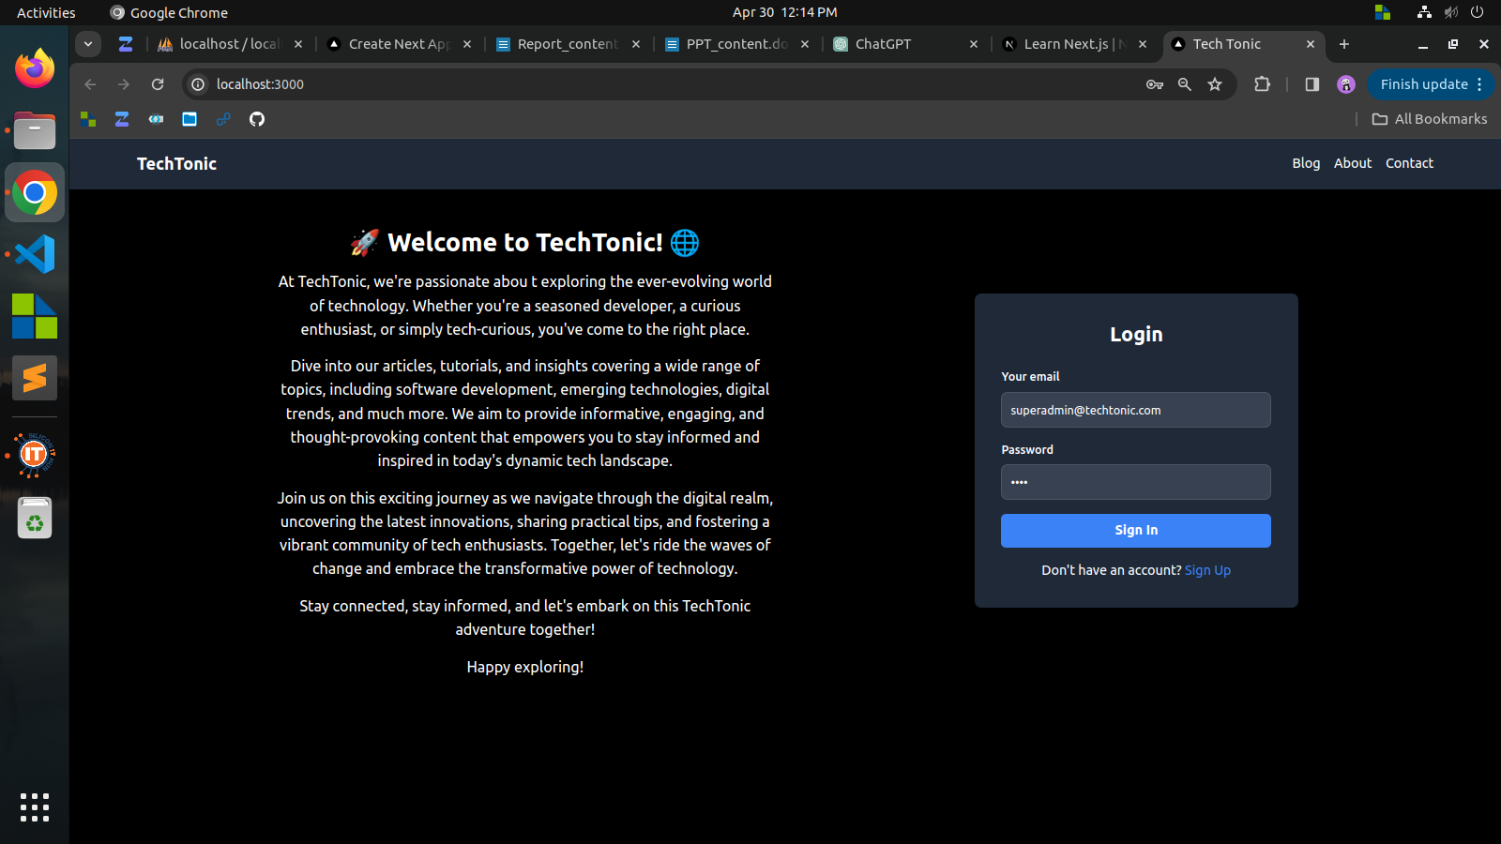

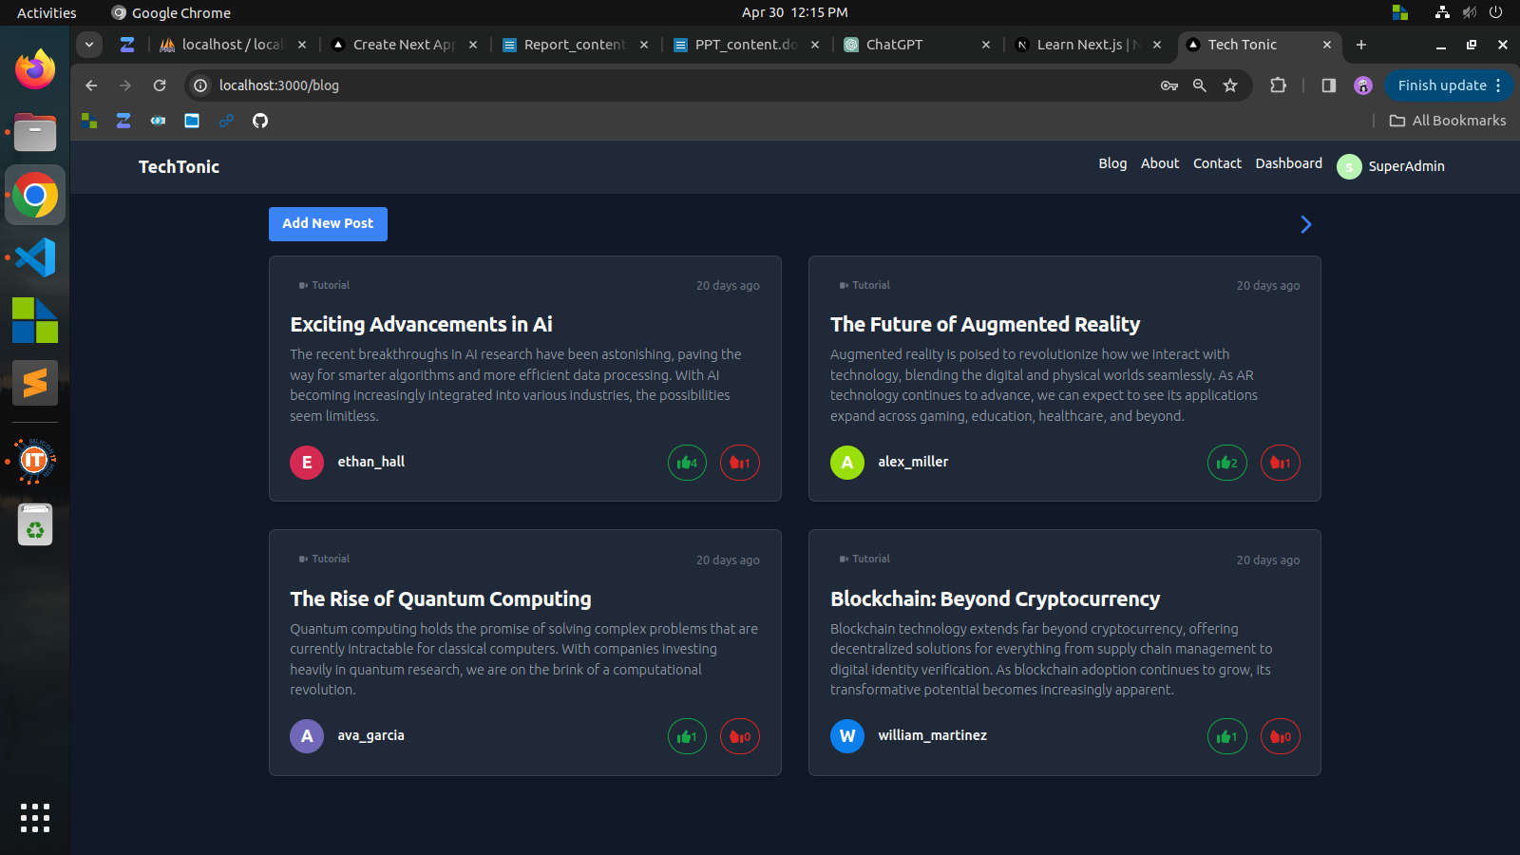

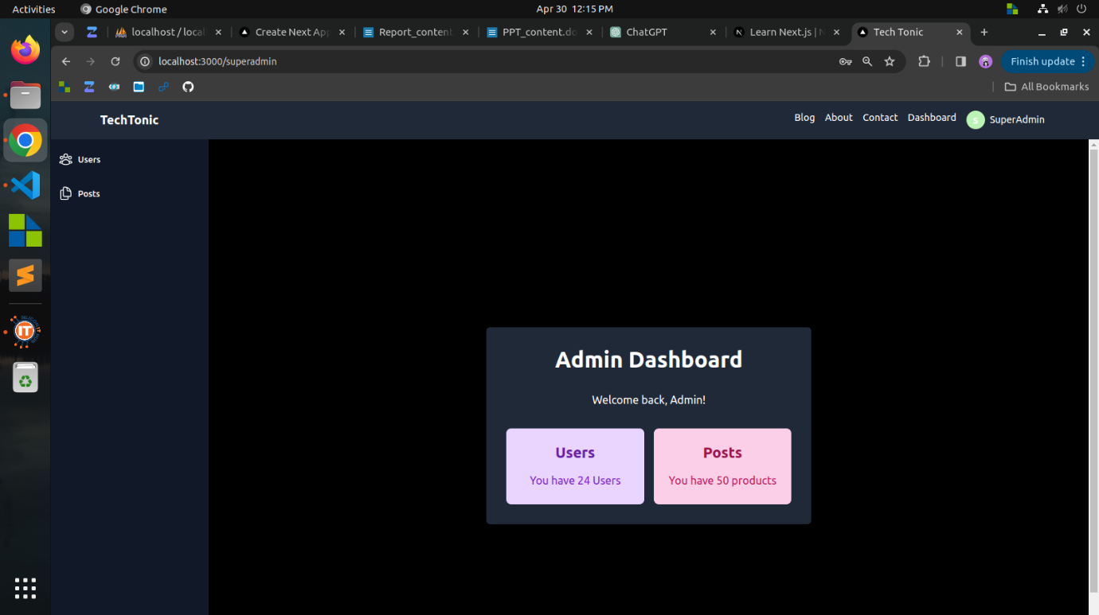

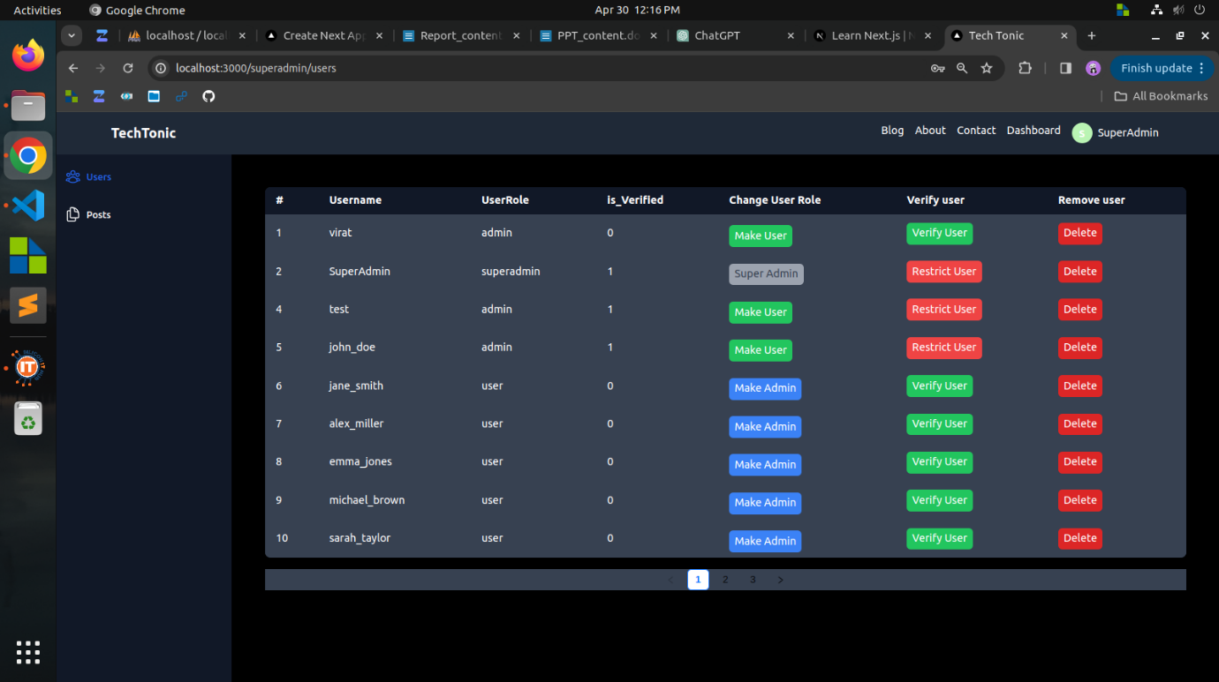

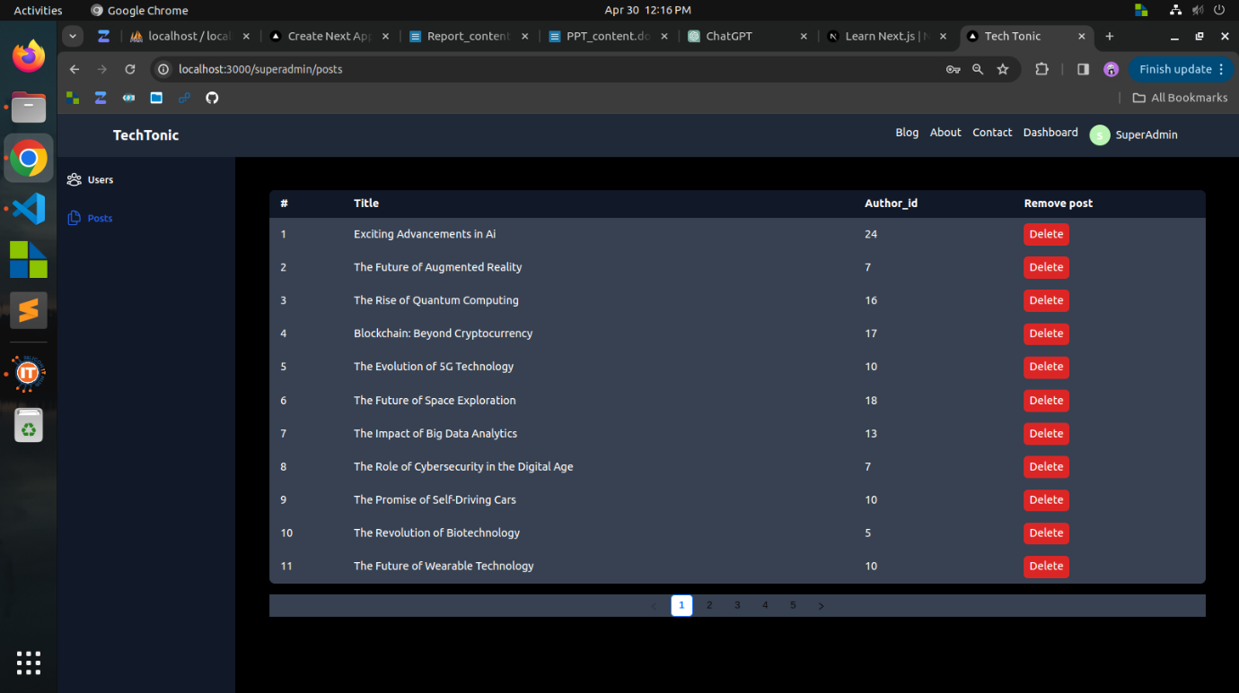

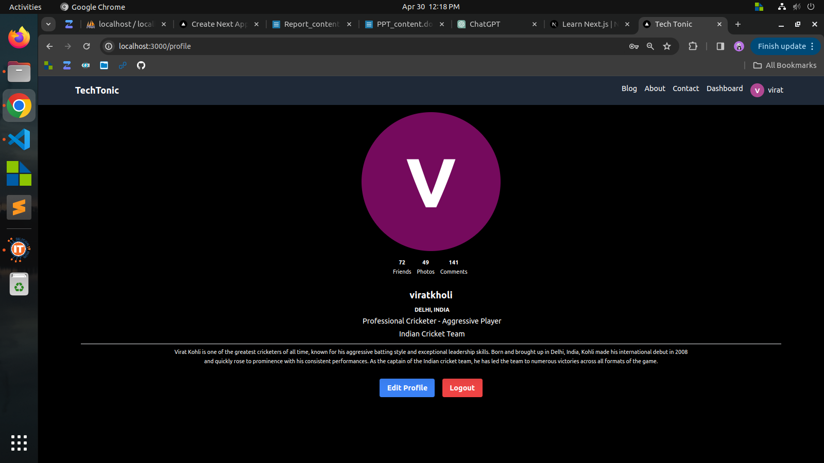

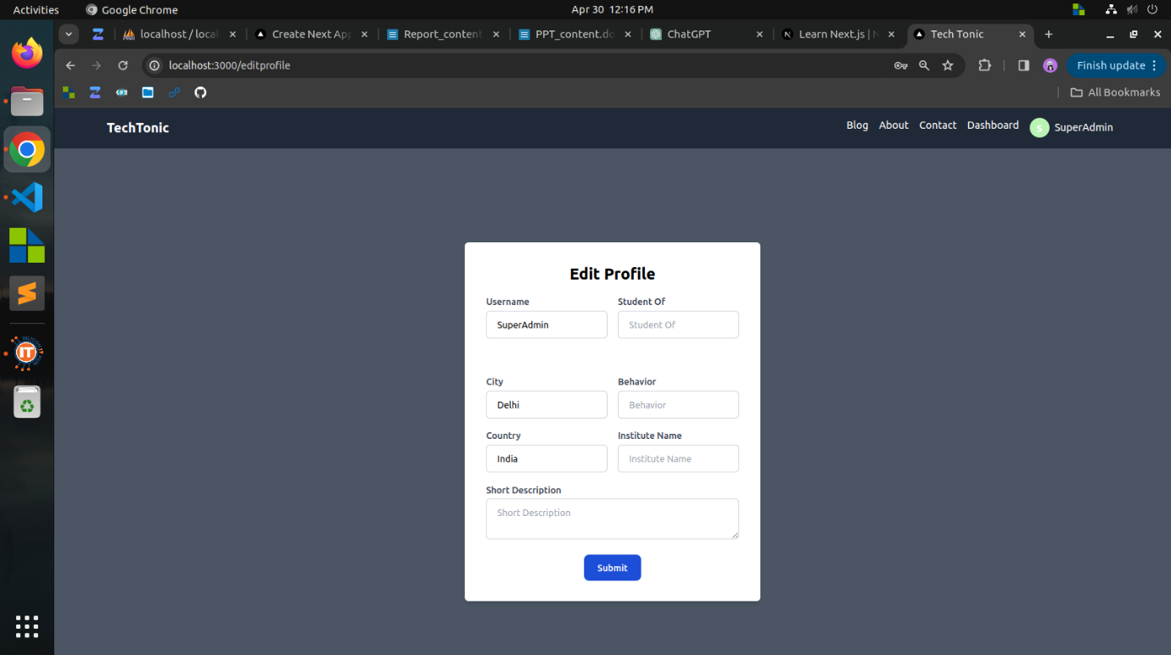

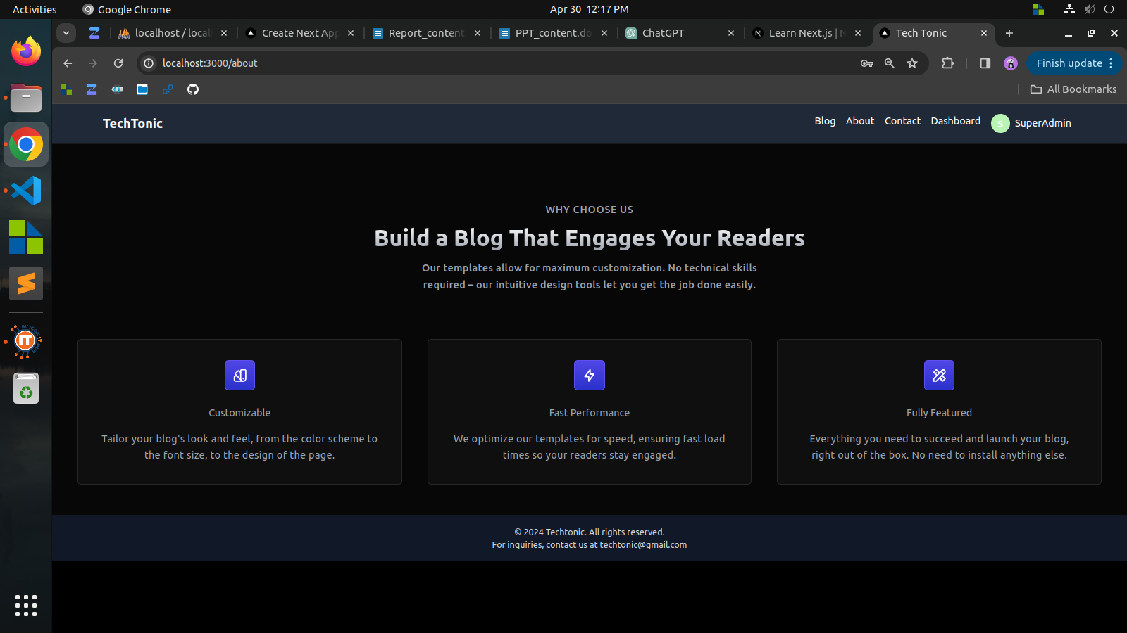

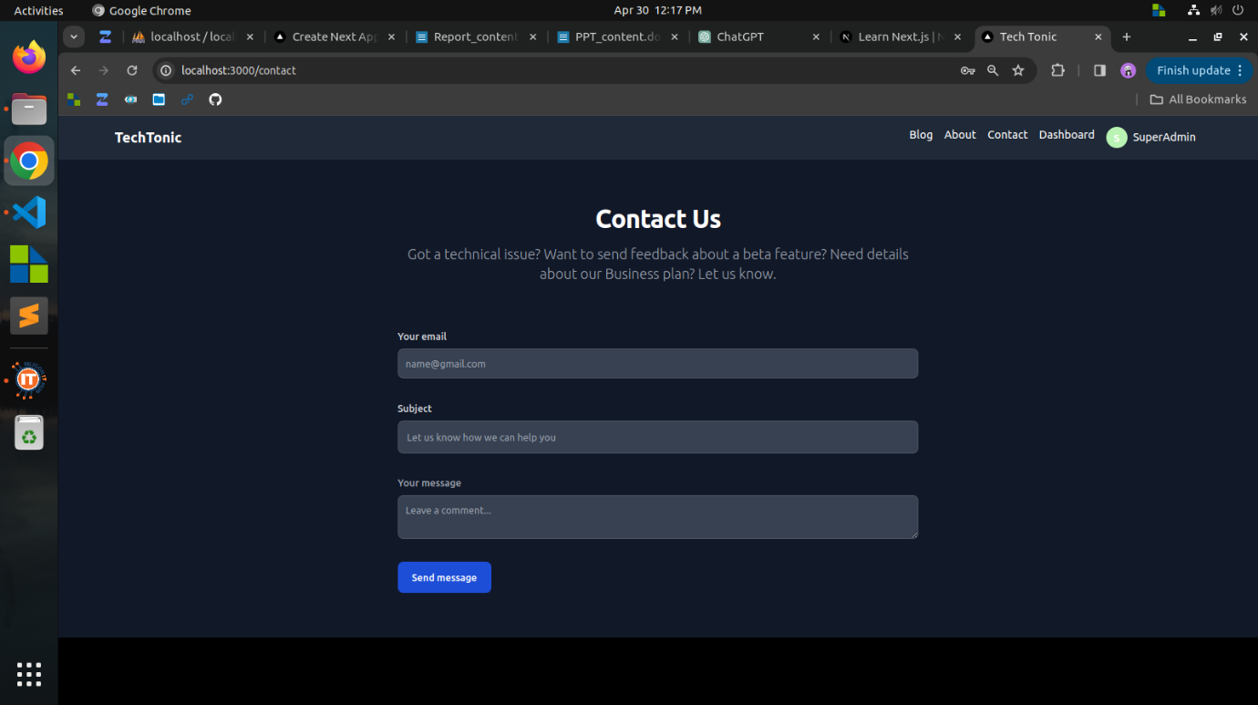

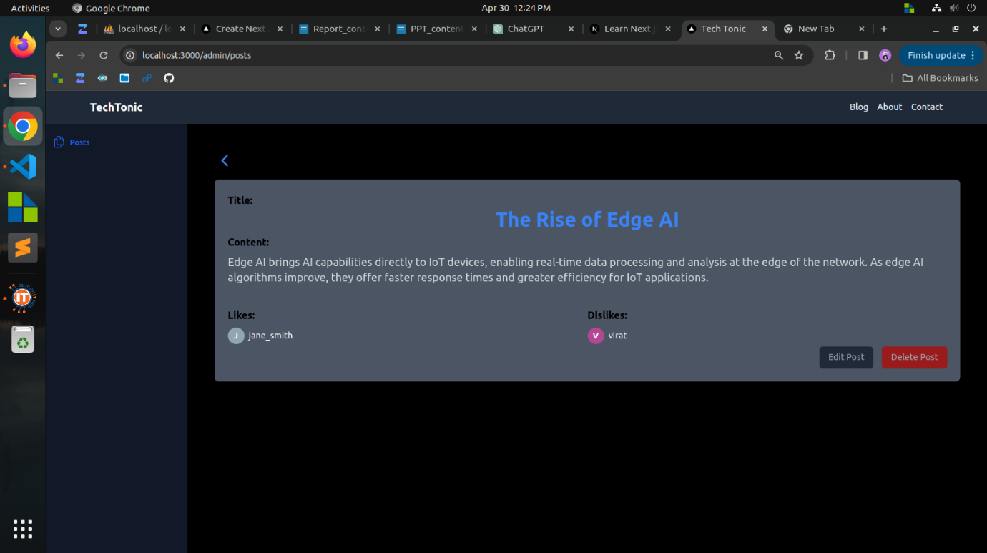

**Week 17**

**Objective:**

In the final week, the aim was to develop a succinct school management system with an admin dashboard, integrating student/teacher management, certificate generation, library, class, fees, transportation, and attendance tracking, streamlining tasks such as updating details, issuing books, generating certificates, taking attendance, managing classes, assigning teachers, and handling transportation logistics.

**Accomplishments:**

**Student and Teacher Management:**

* Implemented functionalities to add, update, and manage student and teacher details within the system.
* Created forms and interfaces for inputting and editing information such as personal details, contact information, and academic records.

**Bonafide Certificate Generation:**

* Developed a feature to generate bonafide certificates for students, incorporating relevant student information and allowing for customization of certificate templates.

**Library Management:**

* Designed a module for library management, enabling the issuance and return of books to students and tracking library inventory.

**Class and Fees Management:**

* Implemented features to store and manage class details, including class schedules, subjects, and assigned teachers.
* Developed functionalities to track and manage student fees, including fee payment records and overdue fee notifications.

**Transportation Management:**

* Created a module for transportation management, allowing for the storage of transportation details for students, including bus routes, stops, and schedules.

**Attendance Tracking:**

* Developed functionality to take and track student attendance, providing insights into student attendance patterns and trends.

**Conclusion:**

In the final week of my internship, I successfully developed a comprehensive school management system encompassing various modules crucial for efficient school administration. The system facilitates tasks related to student and teacher management, library management, class and fees management, transportation management, and attendance tracking. The development of this system marks the culmination of my internship experience, showcasing my ability to design and implement complex software solutions tailored to specific organizational needs. Moving forward, I am confident in my ability to leverage the skills and knowledge gained during this internship to contribute effectively to future projects and endeavors in the field of software development.

**Screen shots:**

